Inductively Coupled Plasma Optical Emission Spectroscopy (ICP-OES) Analysis of Trace Metals in Cigarette Litter collected at McNeese State University in Lake Charles, LA, United States

Liliya Snaychuk,^{1,2} Trey Vaughan,² Zachary Ullery,³ Chris Douvris,¹ Derek D. Bussan^{3*}

1. Department of Biological and Chemical Sciences, New York Institute of Technology, Old Westbury, NY, United States
2. Department of Chemistry, McNeese State University, Lake Charles, LA 70609, United States
3. Department of Chemistry, Eastern Kentucky University, Richmond, KY 40475, United States
* Correspondence: derek.bussan@eku.edu;

Supplemental Information:

Table S1. GPS Locations of Collection Sites.
Location Site Description Latitude Longitude
A Drew Hall, Around Building 30°10'44.13"N 93°13'10.00"W
B Frasch Hall, Parking Lot 30°10'44.21"N 93°13'03.25"W
C Drew Center, HC 30°10'44.20"N 93°13'04.41"W
D Student Services, Left Side 30°10'43.12"N 93°13'16.27"W
E Left end of Kirkman Hall 30°10'42.35"N 93°12'59.32"W
F Frasch Hall Annex, Back Entrance 30°10'47.42"N 93°13'00.21"W
G University Quad 30°10'46.12"N 93°13'00.42"W
H Student Union Annex 30°10'47.6"N 93°13'00.4"W

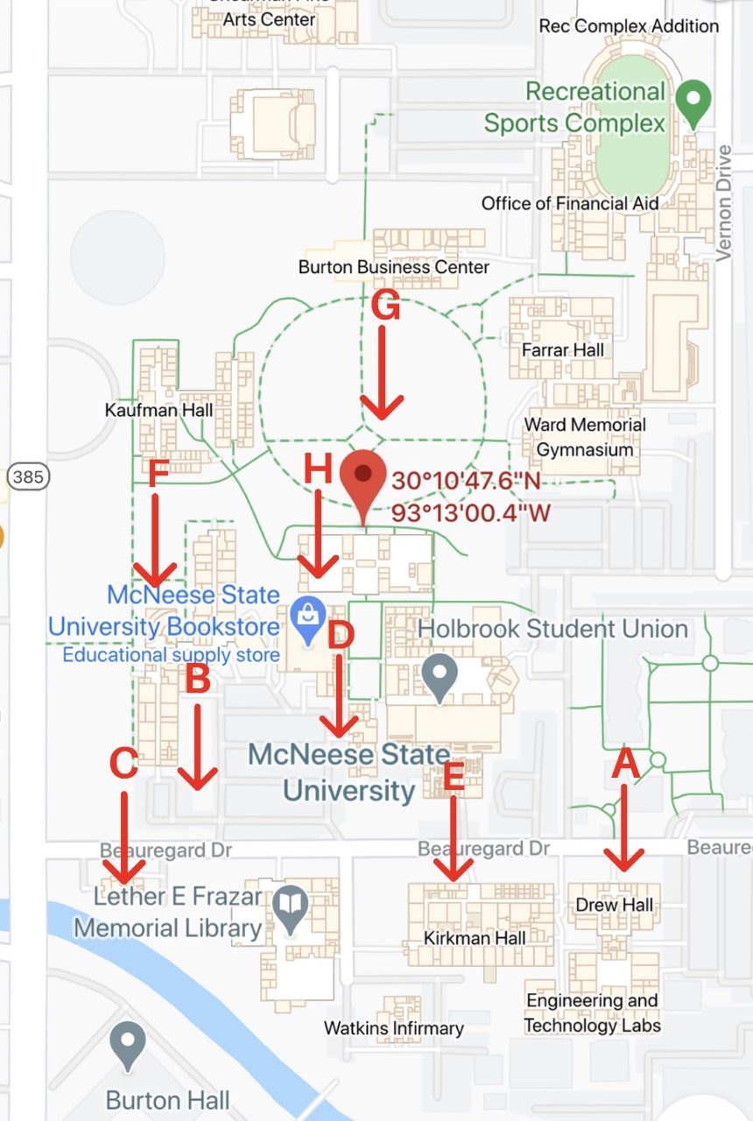

Fig. S1. Location of sample collection sites at McNeese State University in Lake Charles, LA U.S.A.

