Table S1. Proportion Recoveries and Binding Affinity Values of Dipeptide Enantiomers with Human Plasma.
S.NO. Enantiomceorlsumn % Recovery by SPE with Plasma Protein on C18
 |  | Percentage Recoveries | Human Plasma Bindings
 | DD | 43.21 | 56.79
 | DL | 36.61 | 63.39
 | LD | 26.89 | 73.11
 | LL | 15.90 | 84.11

Table S2. The percentage of binding interactions between LD, LL, DL, and DD with human plasma proteins.
S.  No. | pH | DD  %  Recovery | % Binding with plasma protein | DL  %  Recovery | % Binding with plasma protein | LD  %  Recovery | %  Binding with plasma protein | LL  %  Recovery | %  Binding with plasma protein
 |  | 0.10%  TF A  in MeOH |  | 0.10%  TF A  in MeOH |  | 0.10%  TF A  in MeOH |  | 0.10%  TF A  in MeOH
1 | 5 | 22.07 | 79.21 | 13.27 | 86.70 | 19.30 | 80.90 | 22.15 | 79.28
2 | 7 | 38.10 | 61.48 | 18.30 | 83.09 | 24.32 | 77.66 | 19.26 | 82.10
3 | 9 | 42.80 | 58.77 | 35.60 | 65.02 | 27.58 | 72.89 | 16.11 | 83.94
4 | 10 | 40.96 | 59.78 | 15.10 | 84.88 | 25.18 | 76.09 | 15.18 | 86.12

Table S3. Factors of separation (α), retention (k), and Resolution (Rs1,2,3) for LD, DD, DL, and LL- stereomers of dipeptides on the Amy-Coat-RP columns
Retention factors (k) |  |  |  |  | Separation factors (α) |  |  | Resolution factors (Rs)
 | LL (k1) | DD (k2) | DL (k3) | LD (k4) | α1 | α2 | α3 | Rs1 | Rs2 | Rs3
 | 2.25 | 3.60 | 5.00 | 6.50 | 1.60 | 1.39 | 1.30 | 7.76 | 8.05 | 7.19
Number of theoretical plates |  |  |  |  | Tailing factors
 | LL | DD | DL | LD | LL | DD | DL | LD
 | 1156 | 2540 | 5112 | 9216 | 1.00 | 1.21 | 1.15 | 1.11

Table S4. The numerical values of parameters.

S. No. | pH | Pheniramine % | % | Oxybutynin % | % | Cetirizine % | % |  | Brinzolamide %
 | buffer | Recovery | Binding with | Recovery | Binding with | Recovery | Binding with | Recovery |  | Binding with
 |  |  | Plasma protein |  | Plasma protein |  | Plasma protein |  |  | Plasma protein
 |  | 0.1%TFA IN MeOH |  | 0.1%TFA IN MeOH |  | 0.1%TFA IN MeOH |  | 0.1%TFA IN MeOH
 | 5.0 | 25.18  (20.67) | 24.82  (29.33) | 11.24  (13.17) | 37.76  (37.83) | 20.68  (17.59) | 27.32  (34.41) | 19.00  (20.40) |  | 28.50  (32.10)
 | 7.0 | 32.59  (36.40) | 17.41  (13.60) | 10.82  (16.20) | 38.18  (34.80) | 28.61  (22.20) | 19.39  (29.80) | 6.28  (17.59) |  | 41.22  (34.91)
 | 9.0 | 39.0  (42.10) | 11.00  (7.90) | 12.17  (14.89) | 36.83  (36.11) | 27.02  (25.91) | 20.98  (26.09)  ( | 4.70  (15.90) |  | 42.80  (36.60)
 | 10.0 | 35.00  (40.10) | 15.00  (9.90) | 11.00  (13.00) | 38.00  (38.00) | 26.00  (23.5) | 22.00(28.55) | 3.50  (14.2) |  | 44.00  (38.30)

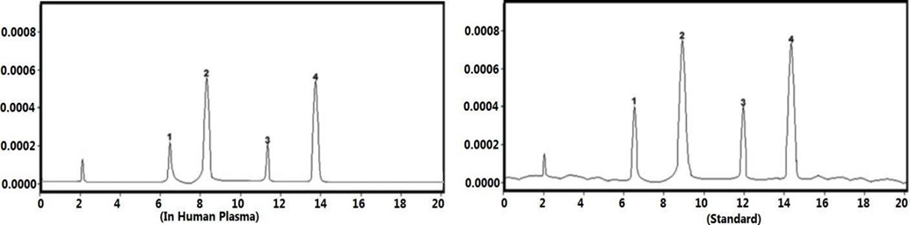
Figure S1. The HPLC chromatograms for the enantiomers of the DL-Leucine-DL-Tryptophan dipeptide. The chromatograms show the following stereoisomers: (1) LL, (2) DD, (3) DL, and (4) LD, in both (a) a human plasma sample and (b) a standard solution.

