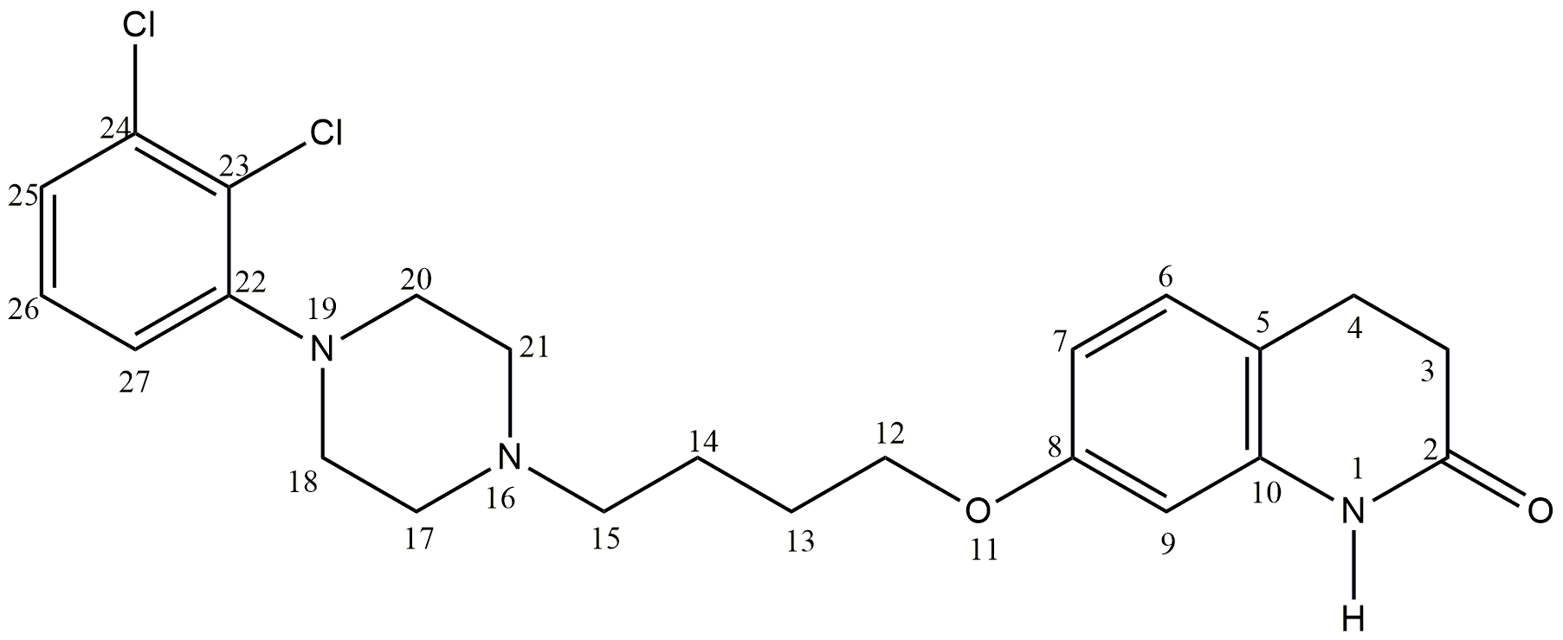
Figure S1: The chemical structure of Aripiprazole

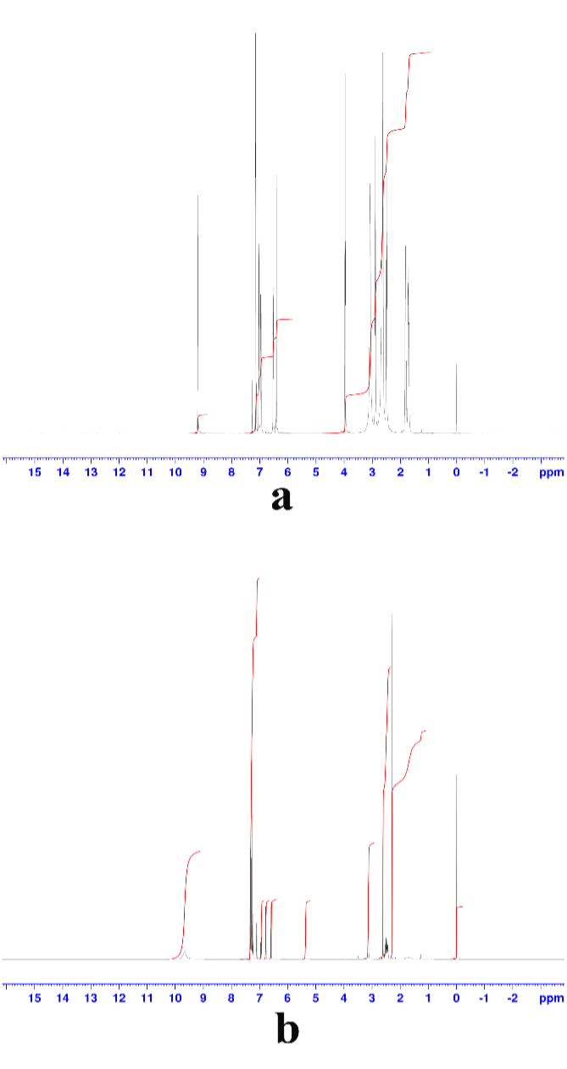
Figure S2: ¹H-NMR spectrum of a: ARP, b: ARP-TCNQ

Table S1: Interpretation of the ¹H-NMR spectrum of ARP
Chemical shift (ppm) | Integral | Multiplicity | H bounded atom No | Implication | J (Hz)
9.19 | 1 | s | 1 | N-H | -
7.14 | 1 | dd | 25 | C-H | 6.6, 3.08
7.12 | 1 | t | 26 | C-H | 6.6
7.03 | 1 | d | 6 | C-H | 8.27
6.95 | 1 | dd | 27 | C-H | 6.6, 3.08
6.51 | 1 | dd | 7 | C-H | 8.27, 2.04
6.40 | 1 | d | 9 | C-H | 2.04
3.96 | 2 | t | 12 | C-H₂ | 6.12
3.07 | 4 | brs | 18,20 | 2(C-H₂) | -
2.88 | 2 | t | 4 | C-H₂ | 7.48
2.63 | 4 | br | 17,21 | 2(C-H₂) | -
2.61 | 2 | t | 3 | C-H₂ | 7.48
2.48 | 2 | t | 15 | C-H₂ | 7.34
1.80 | 2 | m | 13 | C-H₂ | -
1.70 | 2 | m | 14 | C-H₂ | -

Table S2: Interpretation of the ¹H-NMR spectrum of Ari-TCNQ complex
Chemical shift (ppm) | Integral | Multiplicity | H bounded atom No | Implication | J (Hz)
9.66 | 1 | brs | 1 | N-H | -
7.31 | 1 | d | 25 | C-H | 7.62
7.30 | 2 | s | TCNQ | 2(C-H) | -
7.28 | 1 | t | 26 | C-H | 7.62
7.26 | 2 | s | TCNQ | 2(C-H) | -
7.1 | 1 | d | 6 | C-H | 7.16
6.94 | 1 | t | 27 | C-H | 7.62
6.77 | 1 | dt | 7 | C-H | 7.16,1.27
6.58 | 1 | d | 9 | C-H | 1.27
5.30 | 1 | q | TCNQ-ARP | HC=N | 3.9
3.12 | 2 | t | 12 | C-H₂ | 7.7
2.6-2.29 | 18 | m | 3,4,13,14,15,  17,18,20,21 | 9(C-H₂) | -

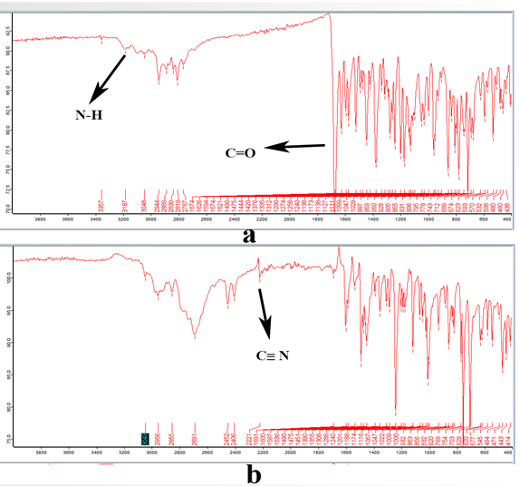
Figure S3: FT-IR spectra of a: ARP, b: ARP-TCNQ

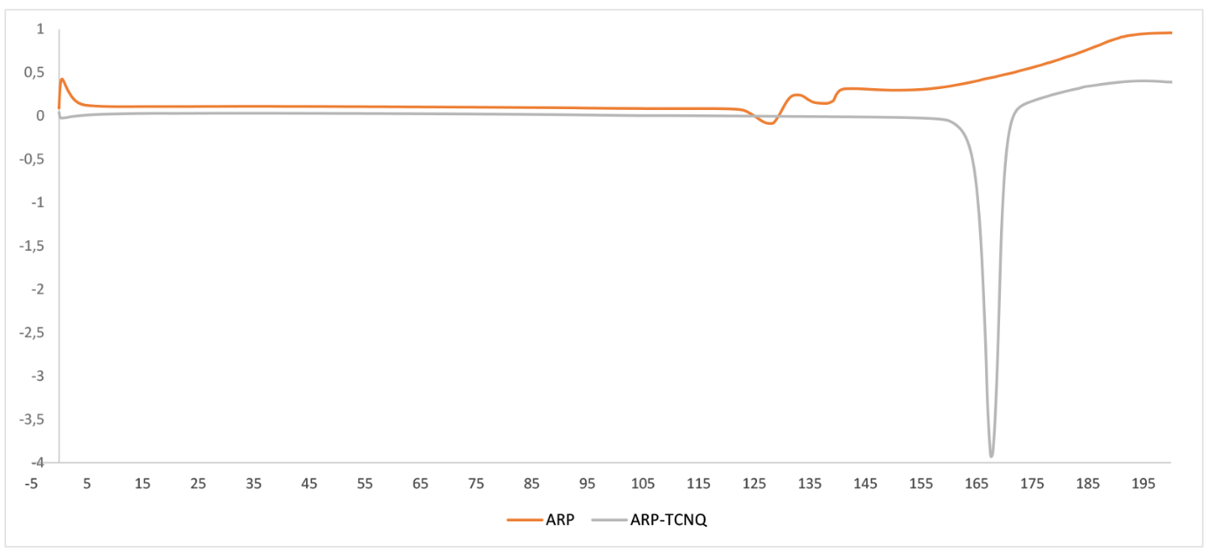
Figure S4: DSC thermogram of ARP and ARP-TCNQ

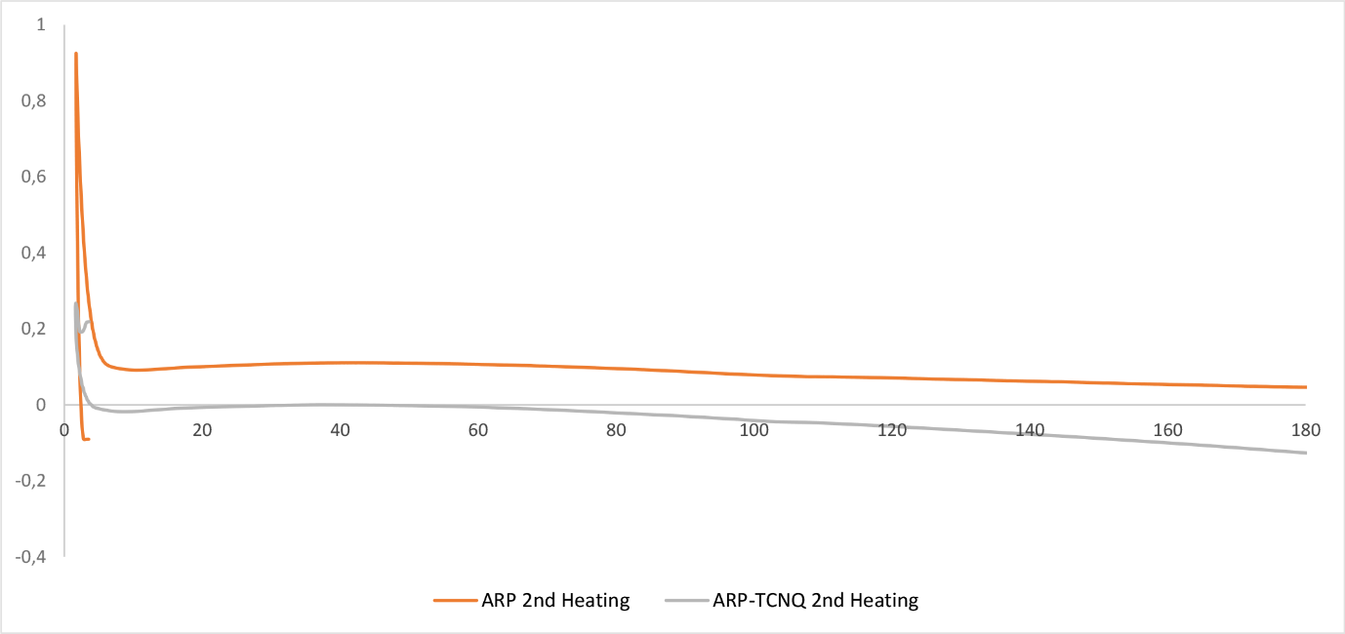

Figure S5: DSC thermogram of ARP and ARP-TCNQ

