Table S1. The composition of the prepared Semi-IPN hydrogels.
Hydrogel | DEMAEMA (g) | Sodium alginate (g) | BisAA (g) | CaCl₂ (% Wt./V) in water
N1 | 1 | 1 | 0.2 | -
N2 | 2 | 1 | 0.4 | -
N3 | 3 | 1 | 0.6 | -
N4 | 1 | 1 | - | 0.5
N5 | 1 | 2 | - | 0.5
N6 | 1 | 3 | - | 0.5

Adsorption Isotherms
$\frac{Ce}{qe}= {\left.\left( \frac{1}{q max. Kl}+ \frac{Ce}{q max}\right.\right)}^{\begin{aligned} \\ \end{aligned}}$ [4]
$ln qe=\ln{Kf+ \frac{1}{n}lnq.}Ce ^{ }$ [5]
Kinetics studies
$\ln\left(qe-qt\right)=lnq1-K1t$ [6]
$\frac{t}{qt}= {\left.\left(\frac{1}{K2.q^{2}}+ \frac{1}{q^{2}}\right.\right). t}^{ }$ [7]
$qt=\left(Kp. t^{1l2} \right)+C$ [8]
Adsorption Thermodynamics
$\ln{K} ={\left.\left(\frac{∆S°}{R} + \frac{∆H°}{RT}\right.\right)}^{ }$ [9]
$∆G°=∆H-T∆S°$ [10]

Figure S1. The swelling ratios of N1-N3 as a function of time
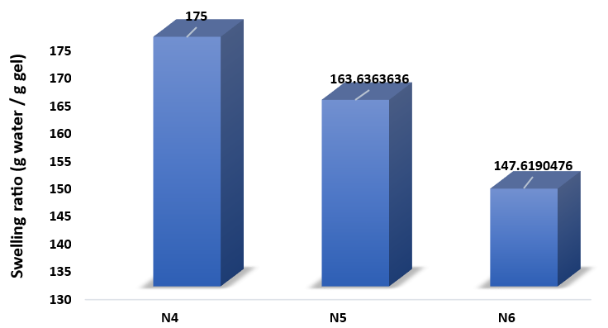
Figure S2. The swelling ratios of N4-N6 at equilibrium state.

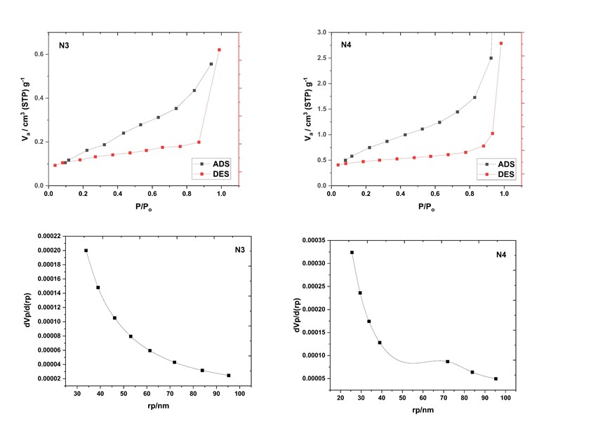
Figure S3. BET and BJH of N3 and N4.
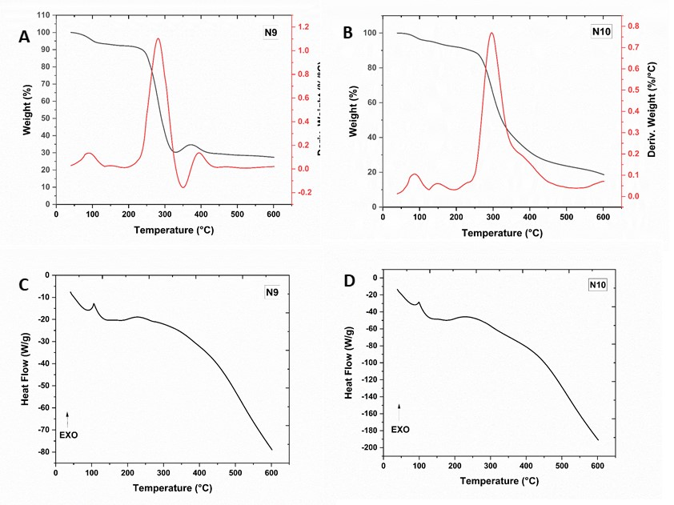
Figure S4. DSC and TGA thermograms of N3 and N4.

Table S2. Thermal analysis data of N3 and N4.
Hydrogel | 1st decomposition state |  |  | 2nd decomposition state |  |  | T50%  ºC | Char content at 600 ºC (%) | Tg ºC
 | T_{i} | T_{f} | Rate of Decomp.  % wt / min | T_{i} | T_{f} | Rate of Decomp.  % wt / min
N3 | 208 | 312 | 0.350 | 372 | 442 | 0.355 | 360 | 21.62 | 93.13
N4 | 211 | 309 | 0.318 | 319 | 447 | 0.080 | 324 | 32.95 | 87.17

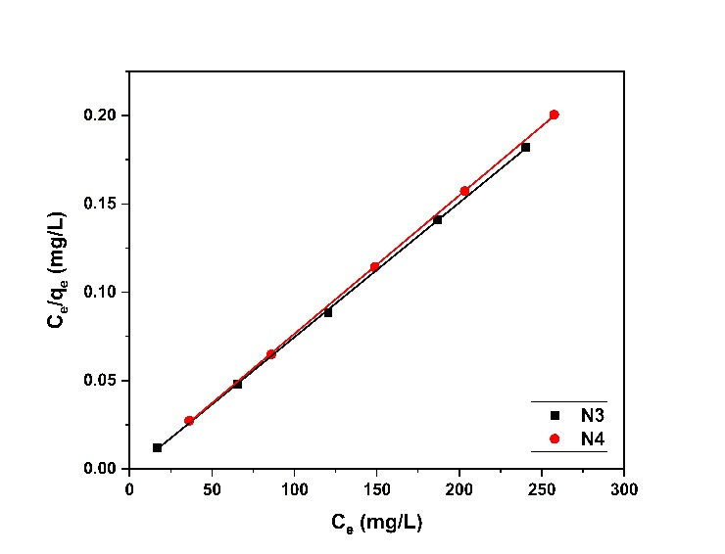
Figure S5. The Langmuir isotherm of CR dye adsorption on the CR dye on prepared N3 and N4 at 35°C.
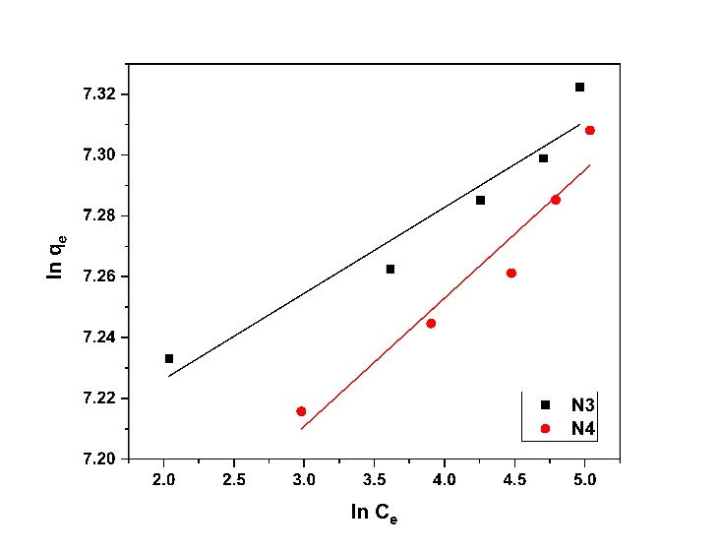
Figure S6. The Freundlich isotherm of CR dye adsorption on the CR dye on prepared N3 and N4 at 35°C.

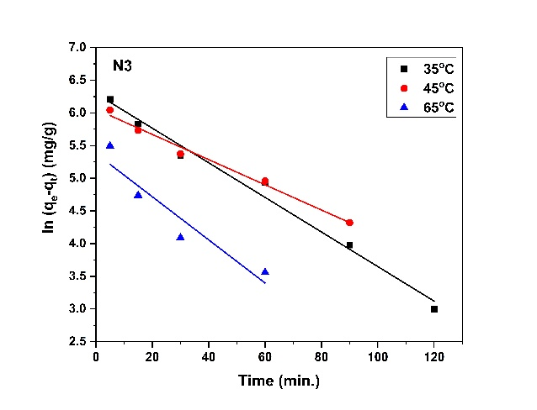 | 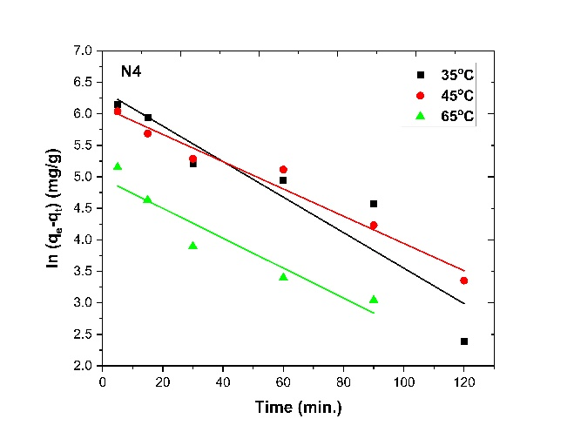

Figure S7. The pseudo-first-order kinetic for the adsorption of CR dye on N3 and N4.

Table S3. The parameters of Pseudo-first order for the adsorption of CR dye on N3 and N4.
K1/N4 | q(theo) | q(exp) | R2/N4 | K1/N3 | q(theo) | q(exp) | R2/N3 | T (⁰C)
0.0282 | 583.883 | 1171 | 0.8815 | 0.0227 | 84.1499 | 1216 | 0.9116 | 35
0.0216 | 448.496 | 1260 | 0.9668 | 0.0637 | 133.166 | 1303 | 0.8218 | 45
0.0237 | 144.676 | 1328 | 0.9055 | 0.1225 | 201.1 | 1365 | 0.7337 | 65

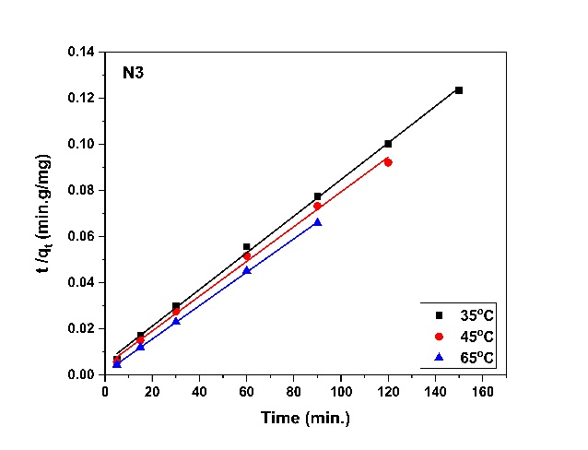 | 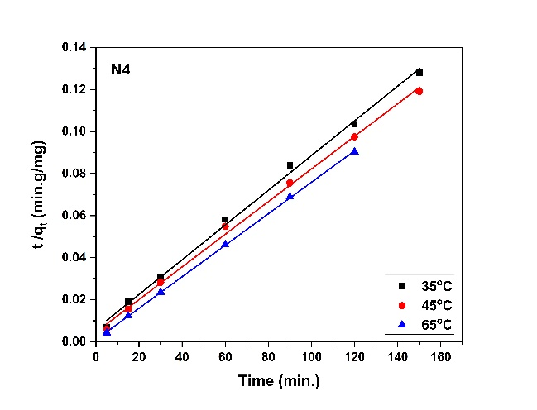

Figure S8. Pseudo-second-order kinetic for the adsorption of CR dye on N3 and N4.

Table S4. The parameters of Pseudo-second-order for the adsorption of CR dye on N3 and N4.
q(theo) | q(exp) | K2/N3 | R2/N3 | q(theo) | q (exp) | K2/N3 | R2/N3 | T(⁰C)
1250 | 1170.7 | 3.84E-09 | 0.8815 | 1250 | 1216 | 2.75E-09 | 0.9976 | 35
1250 | 1259.7 | 2.94E-09 | 0.9668 | 1250 | 1303 | 1.86E-09 | 0.9985 | 45
1428.57 | 1328 | 4.41E-10 | 0.9055 | 1428.571 | 1365 | 5.39E-10 | 0.9998 | 65

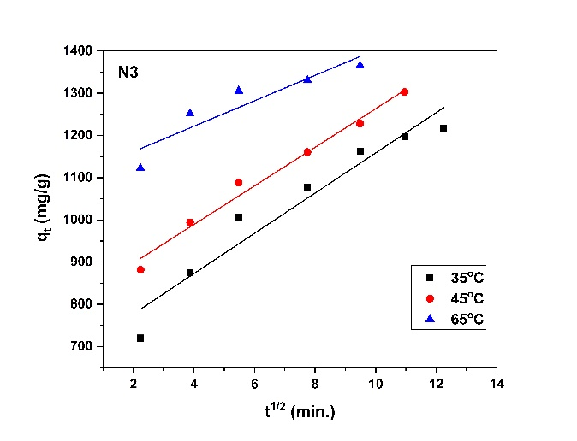 | 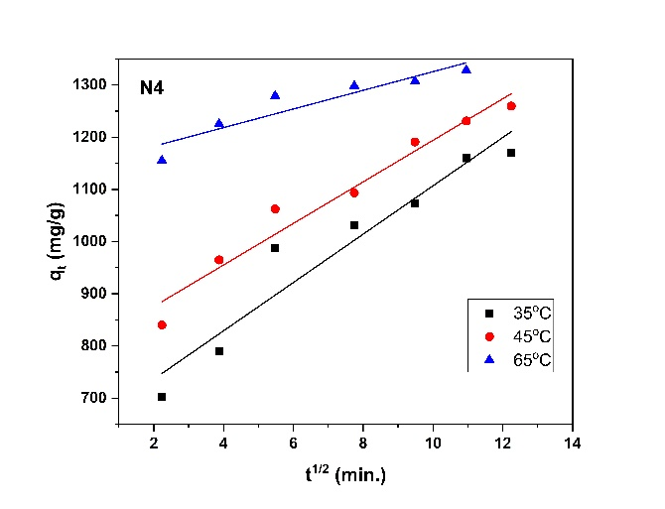

Figure S9. Intra-particle diffusion kinetic for adsorption of CR dye on N3 and N4.
Table S5. The parameters of intra-particle diffusion for CR adsorption on N3 and N4.
Kp/N4 | I/N4 | R²/N4 | Kp/N3 | I/N3 | R²/N3 | T (⁰C)
46.325 | 643.59 | 0.928 | 26.543 | 1743.6 | 0.8599 | 35
39.816 | 795.82 | 0.9598 | 27.673 | 1662.8 | 0.9284 | 45
17.864 | 1146.9 | 0.8694 | 21.52 | 1542.1 | 0.7952 | 65

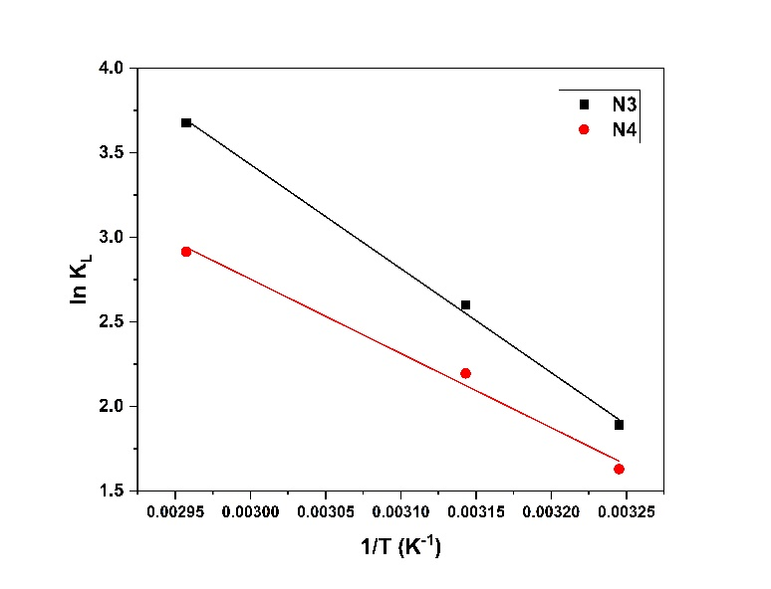
Figure S10. Thermodynamic for adsorption of CR on N3 and N4.

Table S6. The thermodynamic factors and variables for CR dye adsorption on the N3 and N4.
ΔG˚ (kJ/mol.K) | ΔE˚ (kJ/mol.K) | ΔS˚  (J/mol.K) | ΔH˚ (kJ/mol. K) | Temp.  (ºK) | Hydrogel
-4.924 | 48.083 | 181.95 | 51.144 | 308.15 | N3
-6.744 |  |  |  | 318.15
-10.38 |  |  |  | 338.15
-4.29 | 40.549 | 132.400 | 36.506 | 308.15 | N4
-5.61 |  |  |  | 318.15
-8.26 |  |  |  | 338.15
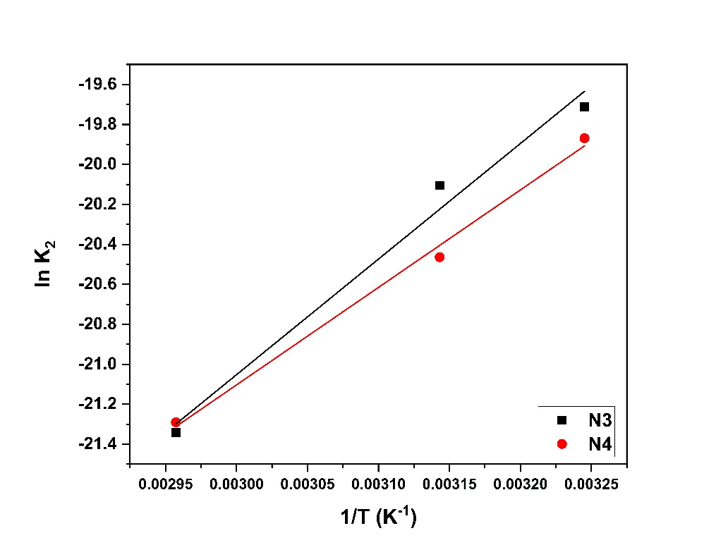
Figure S11. detect activation energy for adsorption of CR dye on N3 and N4.

