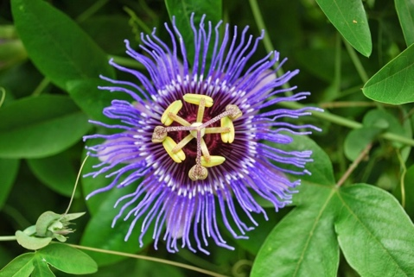
Figure S1. Plant of Passiflora incarnata L.

Table S1. Gradient elution
Gradient Time (min) | Flow rate (mL/min) | % B (mobile phase)
0.00 | 0.35 | 50
1.00 | 0.35 | 50
3.00 | 0.35 | 100
6.00 | 0.35 | 100
7.00 | 0.35 | 50
10.00 | 0.35 | 50

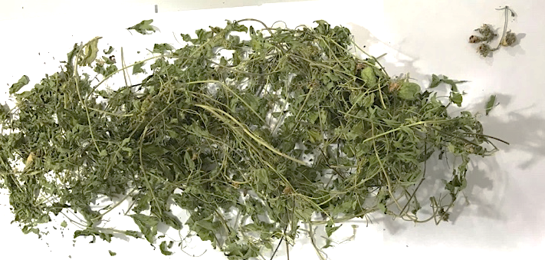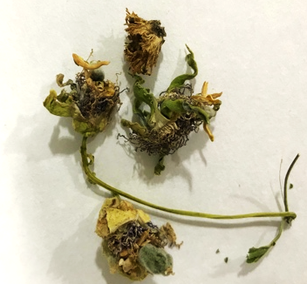
Figure S2. Dried plant materials

Figure S3. Scheme of extraction

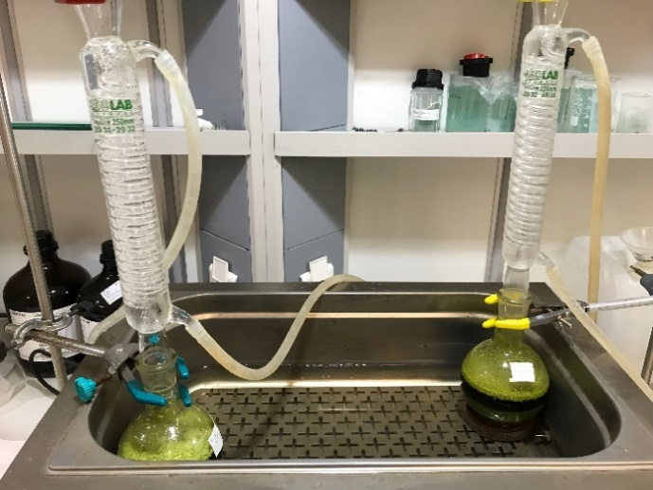
Figure S4. Extraction conducted in a water bath at 60°C under a cooling system

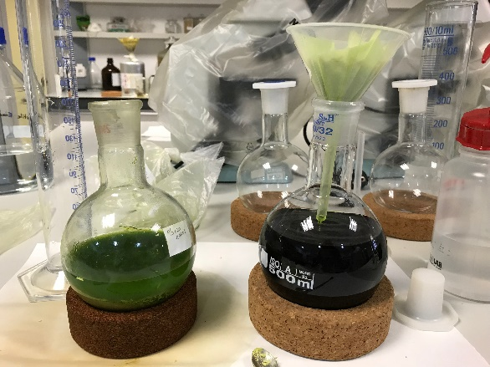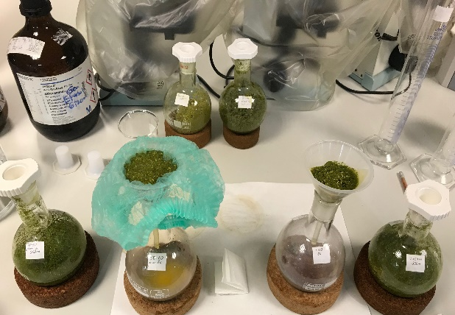
Figure S5. Filtration process after extraction

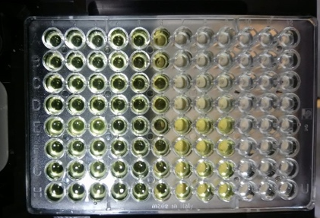
Figure S6. Microplate prepared for the determination of acetylcholinesterase activity test

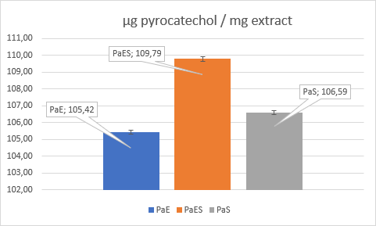
Figure S7. Total phenolic contents of extracts of the ethanol (PaE), water:ethanol (PaES), and aqueous (PaS).
(Correct the significant figures in the figure)
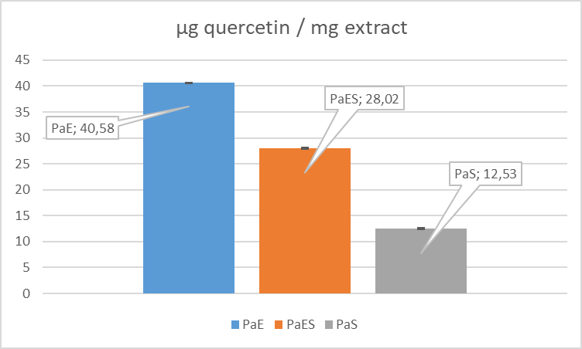
Figure S8. Total flavonoid contents of extracts of the ethanol (PaE), water:ethanol (PaES), and aqueous (PaS).

Table S2. The % inhibition results of the extracts for anti-cholinesterase enzymes
Extracts (200 µg/mL) | AChE (%Inhibition) | BChE (%Inhibition)
PaE | 36,11 ± 0,05 | 28,66 ± 0,46
PaES | 16,00 ± 0,26 | 19,59 ± 0,53
PaS | 31,11 ± 0,37 | 23,21 ± 0,64
Galantamine* | 86,02 ± 0,04 | 92,58 ± 0,06
*standard
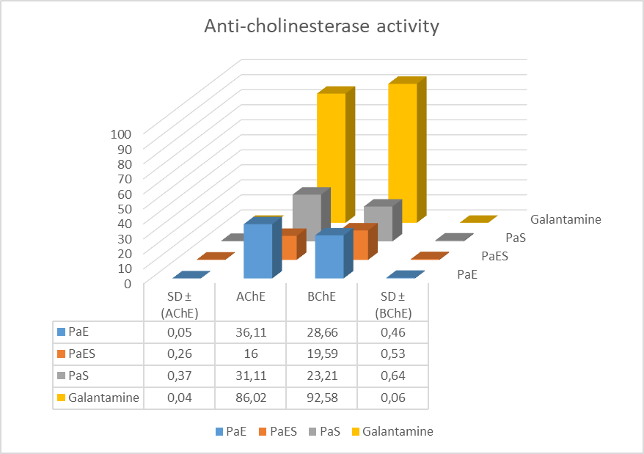
Figure S9. Inhibition of AChE and BChE enzymes by extracts of the ethanol (PaE), water:ethanol (PaES), aqueous (PaS), and its standard deviation values (SD)

Table S3.The results of all compounds were determined of all extracts by LC-HR/MS
COMPOUNDS | Relative Uncertainty (%) |  | Molecular Formula | m/z | Ionization | Lineer Range (μg/mL) | Lineer Regration Equation | LOD/ LOQ | R² | Recovery | RSD (%)
Chlorogenic acid |  | 3.58 | C₁₆H₁₈O₉ | 353.0878 | Neg | 0.05-10 | y=0.00817x+0.000163 | 0.02/0.06 | 0.9994 | 96.68 | 3.93
Orientin |  | 3.67 | C₂₁H₂₀O₁₁ | 447.0933 | Neg | 0.1-10 | y=0.00757x+0.000347 | 0.01/0.03 | 0.9993 | 96.22 | 4.16
Quercitrin |  | 3.78 | C₂₁H₂₀O₁₁ | 447.0933 | Neg | 0.05-10 | y=0.0179x-0.0003331 | 0.01/0.03 | 0.9990 | 97.00 | 4.76
Luteolin-7-rutinoside |  | 3.06 | C₂₇H₃₀O₁₅ | 593.1512 | Neg | 0.1-10 | y=0.00879x+0.000739 | 0.01/0.03 | 0.9988 | 93.05 | 3.84
Luteolin-7-glucoside |  | 4.13 | C₂₁H₂₀O₁₁ | 447.09328 | Neg | 0.5-10 | y=0.02067x-0.002533 | 0.17/0.58 | 0.9984 | 100.46 | 4.45
Rutin |  | 3.07 | C₂₇H₃₀O₁₆ | 609.1461 | Neg | 0.05-10 | y=0.00329x-0.0000558 | 0.01/0.03 | 0.999 | 96.97 | 4.12
Fumaric acid |  | 2.88 | C₄H₄O₄ | 115.0037 | Neg | 0.05-10 | y=0.03122x-0.002136 | 0.01/0.03 | 0.9995 | 103.58 | 3.27
Hyperoside |  | 3.46 | C₂₁H₂₀O₁₂ | 463.0882 | Neg | 0.05-10 | y=0.0072x-0.00003096 | 0.01/0.03 | 0.9995 | 96.62 | 3.77
Naringenin |  | 4.20 | C₁₅H₁₂O₅ | 271.0612 | Neg | 0.1-10 | y=0.0281x+0.00182 | 0.01/0.03 | 0.9995 | 86.65 | 4.20
Luteolin |  | 3.42 | C₁₅H₁₀O₆ | 285.0405 | Neg | 0.1-10 | y=0.117x+0.00848 | 0.01/0.03 | 0.9981 | 96.98 | 4.77
Acacetin |  | 3.98 | C₁₆H₁₂O₅ | 283.0612 | Neg | 0.05-7 | y=0.046x+0.0001875 | 0.01/0.03 | 0.9995 | 87.52 | 3.55
Chrysin |  | 3.24 | C₁₅H₁₀O₄ | 253.0506 | Neg | 0.05-7 | y=0.0964x-0.0002622 | 0.01/0.03 | 0.999 | 87.92 | 2.36
(-)-Epicatechin |  | 3.17 | C₁₅H₁₄O₆ | 289.0718 | Neg | 0.05-10 | y=0.0172x+0.0002269 | 0.01/0.03 | 0.9993 | 95.66 | 3.37

