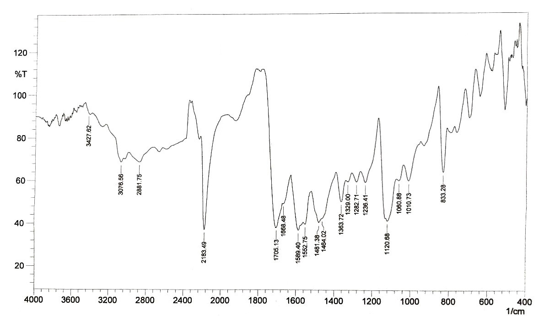
Figure S1. IR Spectrum of the reaction between 5-amino-2-hydroxybenzoic acid and diazotized IMID.

Figure S2. H-NMR Spectrum of the reaction between 5-amino-2-hydroxybenzoic acid and diazotized IMID

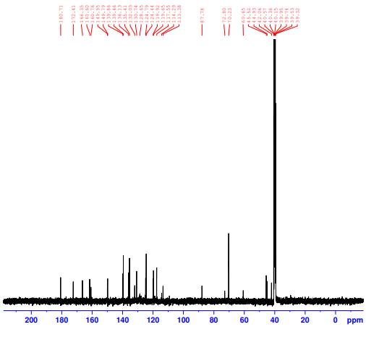
Figure S3. C-NMR Spectrum of the reaction between 5-amino-2-hydroxybenzoic acid and diazotized IMID

Figure S4. The effect of volumes of IMID, 5-amino-2-hydroxybenzoic acid, NaNO₂, HCl, H₃NSO₃, and NaOH on the diazotization compound formation.
Figure S5. Effect of time on (a) the diazotization salt formation and break down time of nitrous acid, (b)the stability of IMID-P.

Figure S6. Molar ratio for the reaction of IMID and with 5-amino-2-hydroxybenzoic acid.

Figure S7. Jobs method for IMID reaction with 5-amino-2-hydroxybenzoic acid.

Figure S8. Calibration curve for the reaction between IMID and 5-amino -2-hydroxybenzoic acid

