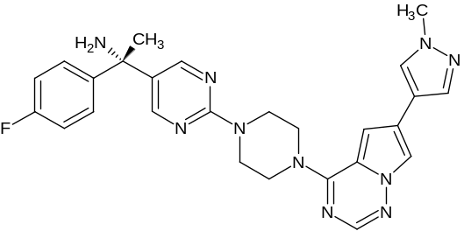
Figure S1: Molecular structure of avapritinib

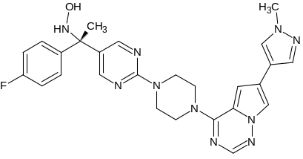 | 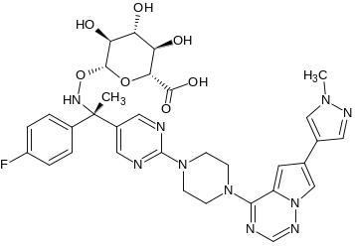 | 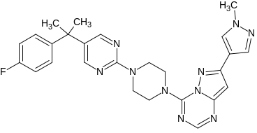
Impurity 1 | Impurity 2 | Impurity 3
Figure S2: structure of avapritinib impurities selected in this study

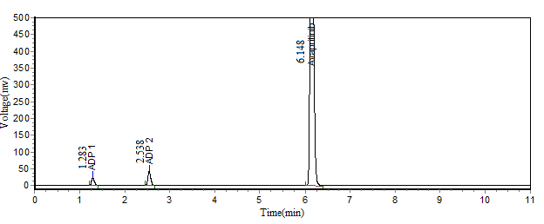
a
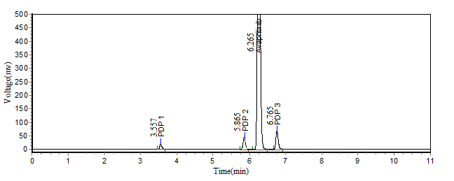
b
Figure S3: Acid (a) and photolytic (b) degradation chromatograms of avapritinib
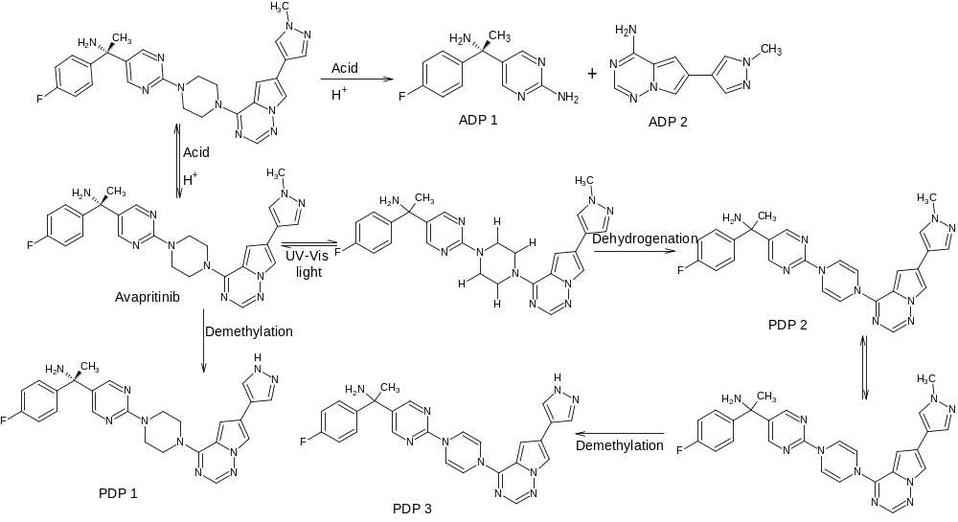Figure S4: Mechanism of formation of DPs

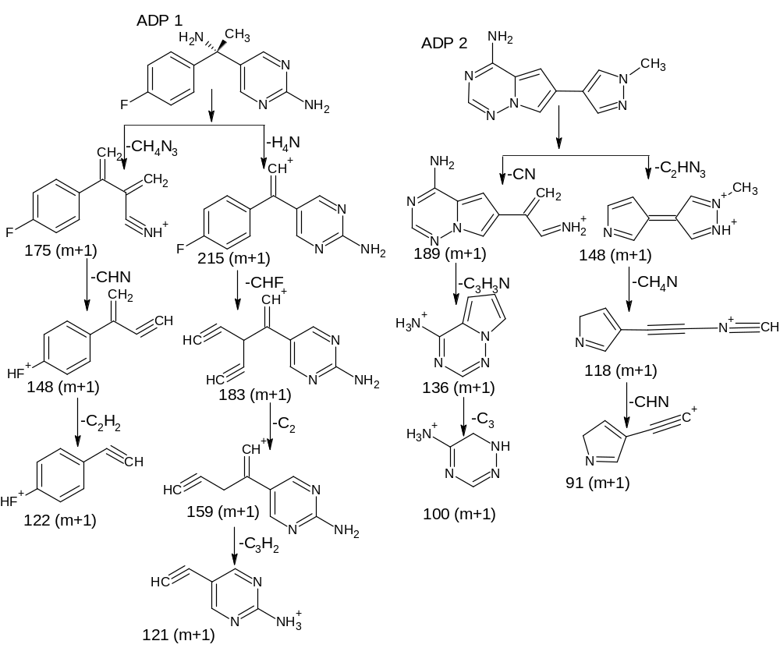
Figure S5: Fragmentation pathway of ADP 1 and ADP 2
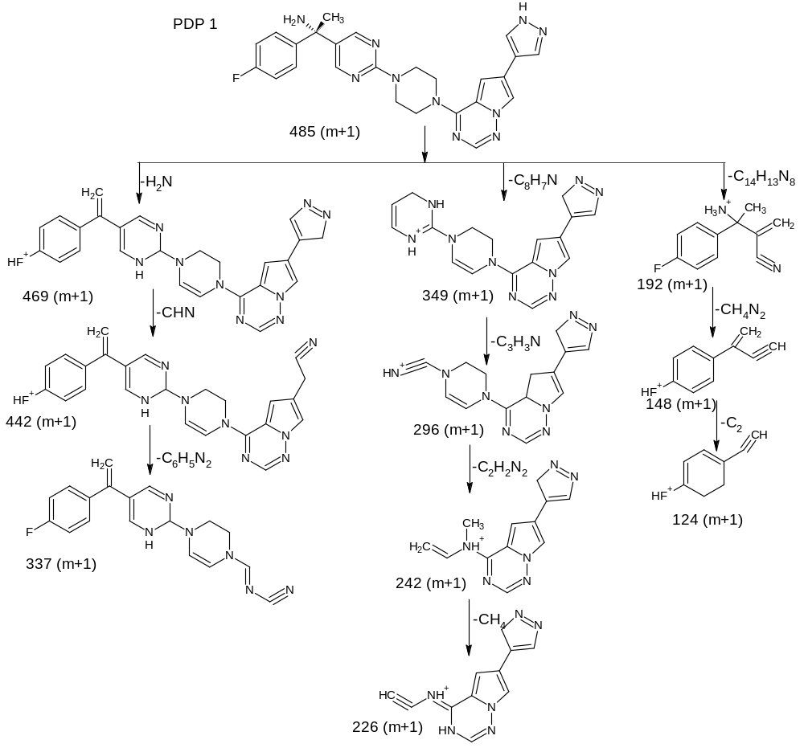
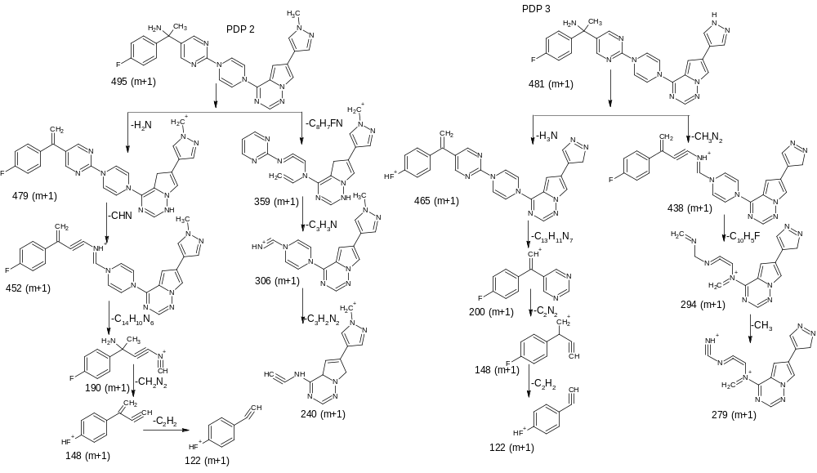
Figure S6: Fragmentation pathway of PDP 1, PDP 2 and PDP 3
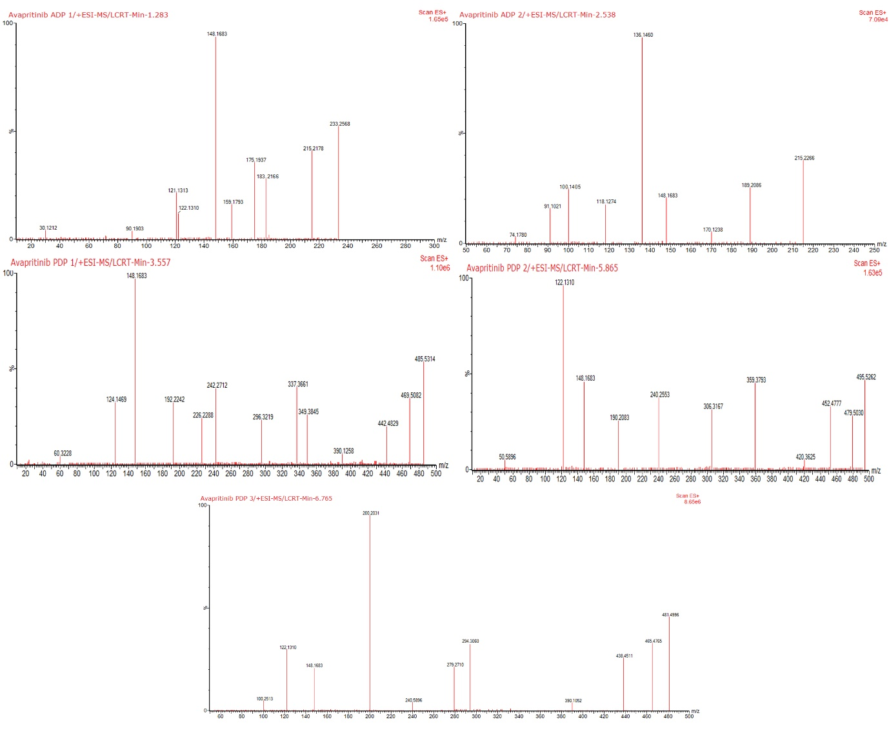
E
D
C
B
A
Figure S7: Mass spectra of ADP 1(A), ADP 2 (B), PDP 1 (C), PDP 2 (D), and PDP 3 (E)

