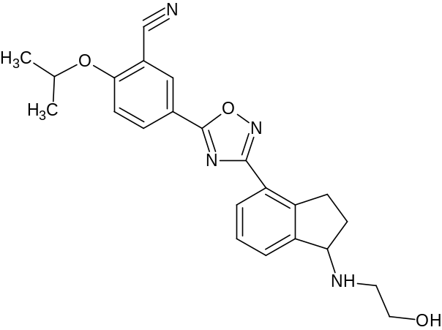
A) Ozanimod
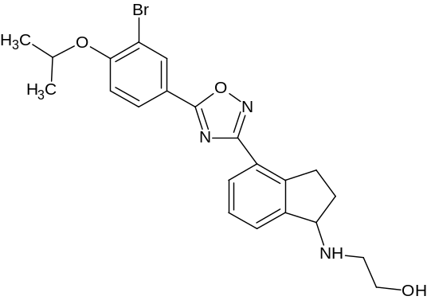 | 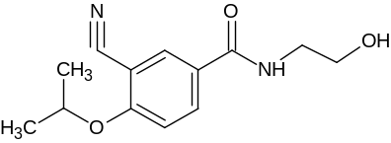
B) Bromo impurity | C) Hydroxy amide impurity
Figure S1: Molecular structure of Ozanimod and studied impurities

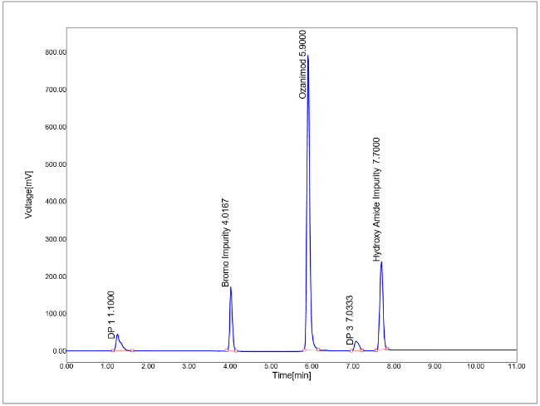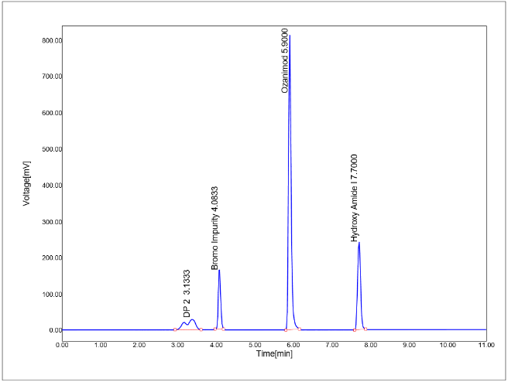
A B
Figure S2: Acid (A) and Base (B) degradation chromatogram that resolve DP 1, 2 and 3 along with known impurities and standard Ozanimod in the proposed method
Table S1. Forced degradation conditions for Ozanimod
Condition | Stressor | Conditions | Duration | % degradation | DPs
Acid | HCl (2N) | 8 hours at 80°C | 8 days | 15.98 | DP 1 & DP 3
Base | NaOH (3 N) | 8 hours at 80°C | 8 hours | 11.21 | DP 2
Oxidative | H₂O₂ (30%) | Room temperature | 3 days | 4.52 | ---
Thermal | --- | 80°C | 2 days | 2.16 | ---
UV | 200 W h/m2 | Room temperature | 3 days | 5.77 | ---

Table S2. Elemental composition study results of Ozanimod, impurities, and its DPs.
Compound | MF | m/z Calculated | m/z observed | Error in ppm | Fragmentation  (m+1)
DP 1 | C₁₈H₁₅N₃O₄ | 338.3291 | 338.3294 | 0.89 | 322.3062  265.2980  210.1782  159.2191  183.1528
DP 2 | C₂₁H₂₂N₄O₃ | 379.4240 | 379.4243 | 0.79 | 338.3520  293.3114  251.2747  175.2218  92.1299
DP 3 | C₂₁H₂₀N₄O₂ | 361.4089 | 361.4091 | 0.55 | 320.3367  253.2906  175.2218  92.1299

Table S3. Precision and ruggedness results of Ozanimod and its impurities
S No | Analyte | % Assay | % RSD in Intraday precision | % RSD in Interday precision |  | % RSD in Ruggedness
 |  |  |  | Day 1 | Day 2 | % RSD in Ruggedness
1 | Ozanimod | 99.30 | 0.89 | 0.65 | 1.27 | 0.29
2 | Bromo Impurity | 98.76 | 0.64 | 0.38 | 0.23 | 0.87
3 | Hydroxy Amide Impurity | 98.80 | 0.49 | 0.41 | 0.68 | 0.91

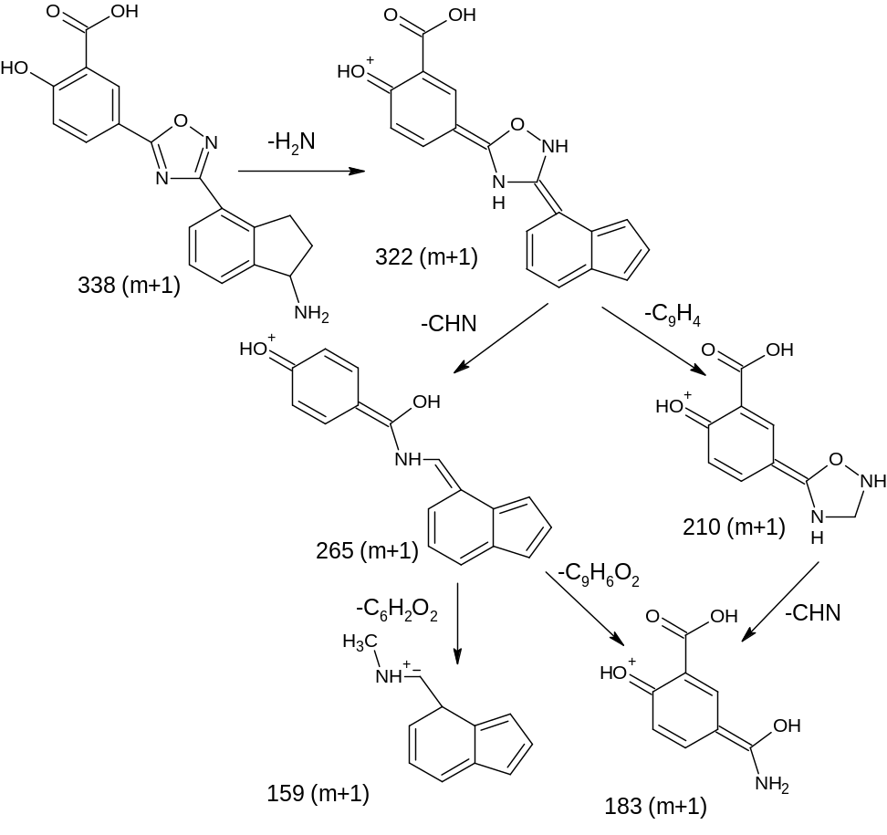
Figure S3: Degradation pathway for DP 1

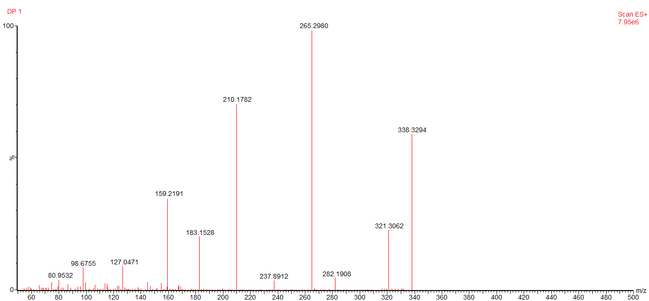
Figure S4: Mass spectrum of DP 1
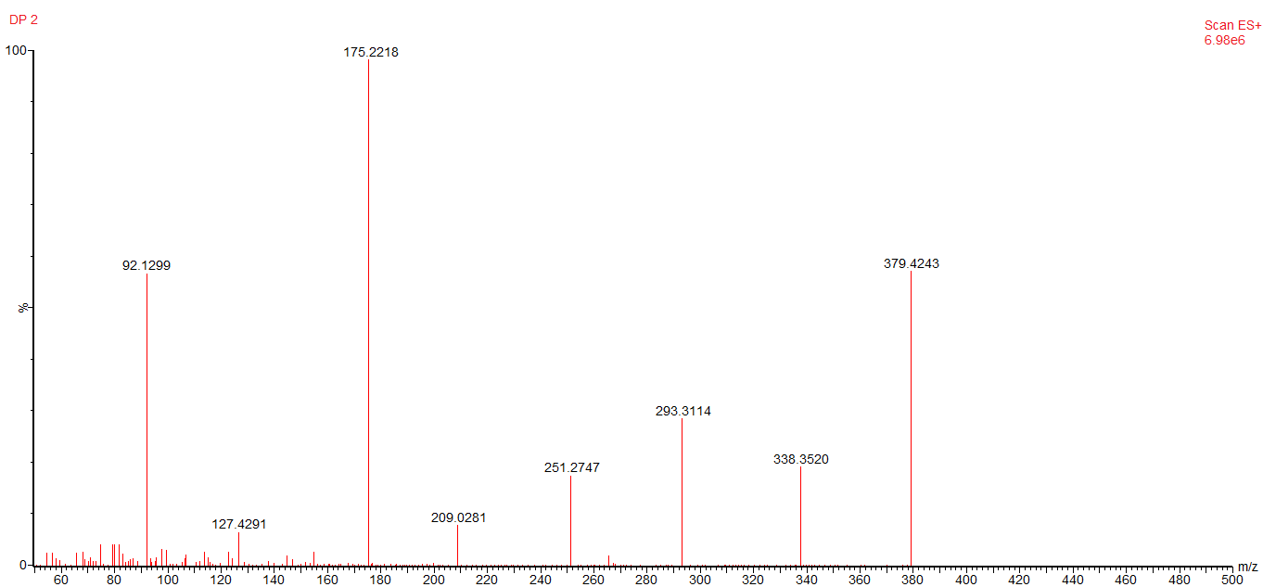
Figure S5: Mass spectrum of DP 2

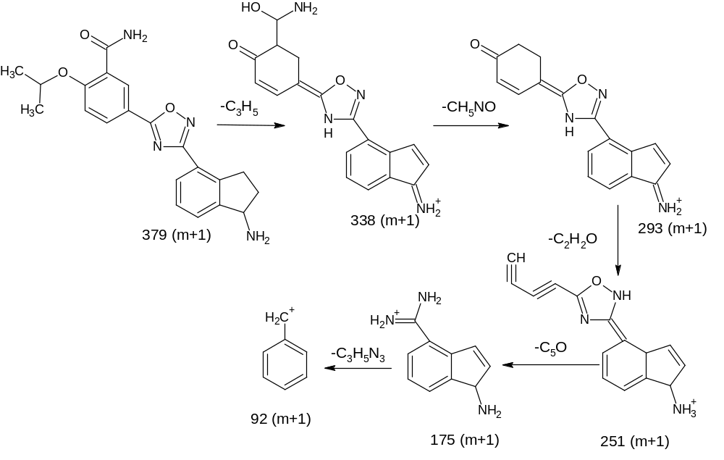
Figure S6: Degradation pathway for DP 2
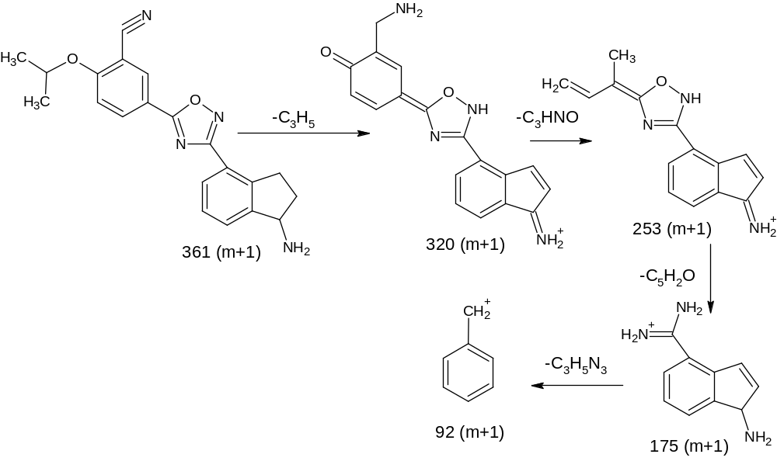
Figure S7: Degradation pathway for DP 3

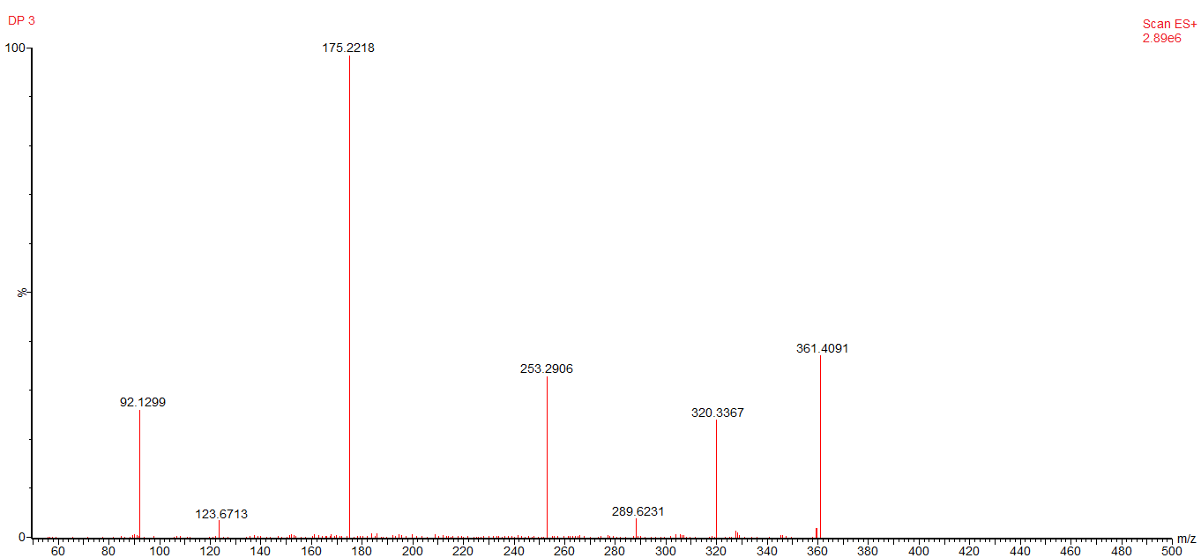
Figure S8: Mass spectrum of DP 3

Table S4. Robustness results of Ozanimod
Condition changed | Resolution between Ozanimod and hydroxy amide impurity | Tailing factor | Theoretical plates | % Assay
ethanol and orthophosphoric acid in 75:25 (v/v) | 11.21 | 0.93 | 17632 | 98.08
ethanol and orthophosphoric acid in 65:35 (v/v) | 11.08 | 1.08 | 17982 | 99.55
0.75mL/min flow rate | 11.16 | 1.02 | 17092 | 98.73
0.65mL/min flow rate | 11.04 | 0.99 | 17883 | 98.23
254 nm wavelength | 11.38 | 0.93 | 17634 | 100.93
244 nm wavelength | 11.29 | 1.01 | 17892 | 98.44

Table S5. Solution stability of Ozanimod
Time Interval | Standard | Sample
0 hour (Initial) | 98.34 | 99.14
24 hours (after) | 98.13 | 98.99
48 hours (after) | 98.07 | 99.01
% difference | 0.27 | 0.13

