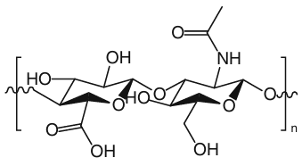
Fig. S1. Chemical structure of HA.

$$u_{Combined}=\sqrt{{\left(u_{standard}\right)}^{2}+{\left(u_{weighing}\right)}^{2}+{\left(u_{recovery}\right)}^{2}+{\left(u_{curve}\right)}^{2}}$$
Formula S1. Equation for Combined Uncertainty Calculation.

Table S1. Suitability parameters of the chromatographic system.
Capacity Factor | Resolution | HETP | Tailing Factor | Asymmetry Factor
7.71 | 2.8 | 0.06 | 1.1 | 0.7
* Values represent the average parameter measurements obtained from calibration analysis.

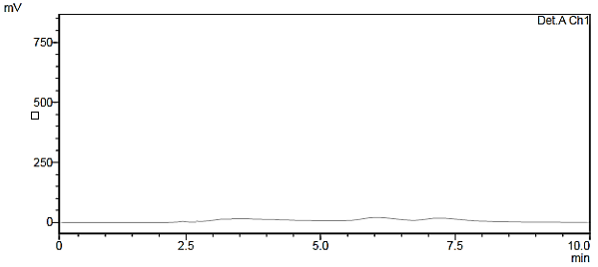
(a)
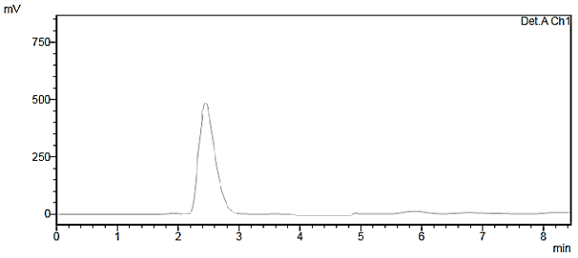
(b)
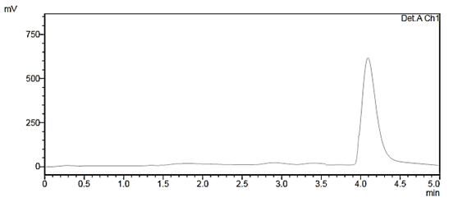
(c)
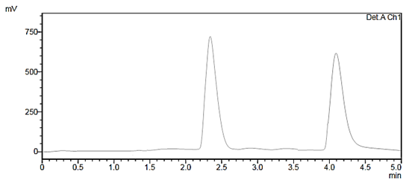
(d)
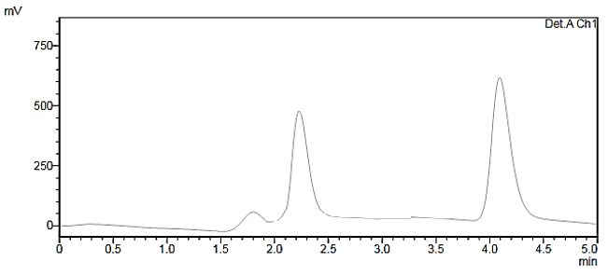
(e)
Fig. S2. Chromatograms of various samples: (a) Blank (aqueous medium), (b) Standard solution (10 µg/mL HA), (c) Blank cream sample, (d) Cream sample spiked with 20 µg/mL HA, (e) Real cream sample.

Table S2. Robustness of the method.
Condition | Value | Recovery % | RSD %
Flow rate mL min⁻¹ | 0.8  1.0 | 95.90  96.88 | 0.79  1.10
Mobile phase composition (Acetonitrile:Buffer solution) | 75:25  85:15 | 93.17  95.06 | 0.46  0.95
Column temperature (°C) | 25  35 | 100.40  101.27 | 0.24  0.36
Note: n=3 for all QC sample levels.

Table S3. Combined and expanded uncertainty results.
 |  | Uncertainty (U) in %
Analyte | U_{Standard} | U_{Calibration} | U_{Recovery} |  | U_{Repeatability} U_{Combined} U_{Expanded}
HA | 0.316 | 1.204 | 0.318 |  | 2.108 2.005 3.963

