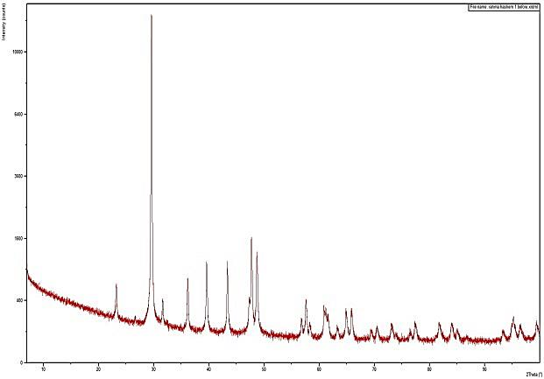  A | 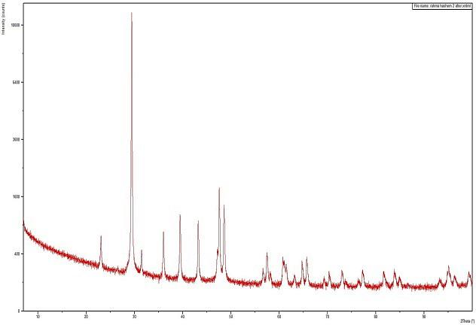  B
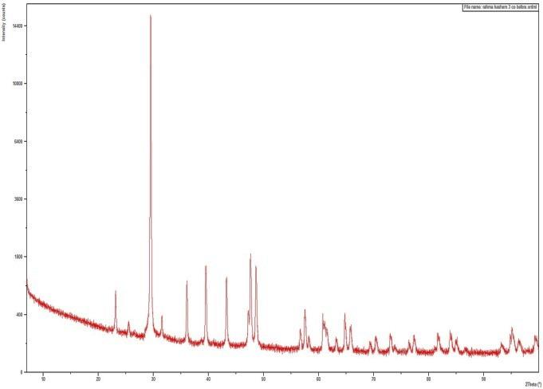  C | 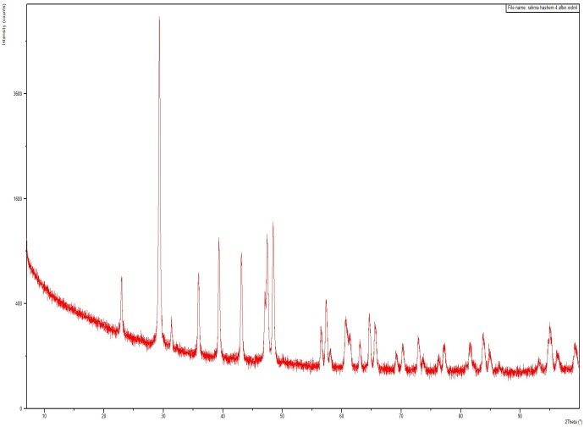  D

Figure S1. XRD patterns of eggshell samples: (a) untreated ES before Co(II) adsorption; (b) ES after Co(II) adsorption; (c) acid-treated EST before adsorption; and (d) EST after Co(II) adsorption.

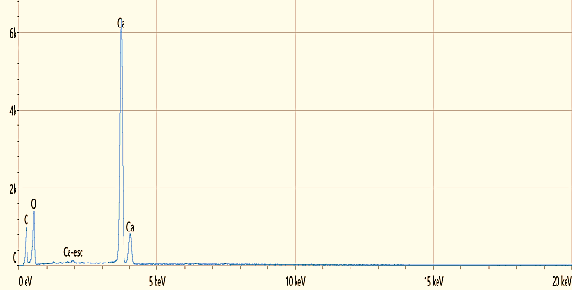
Element | Atomic %
C | 19.4
O | 61.2
Ca | 19.4

a
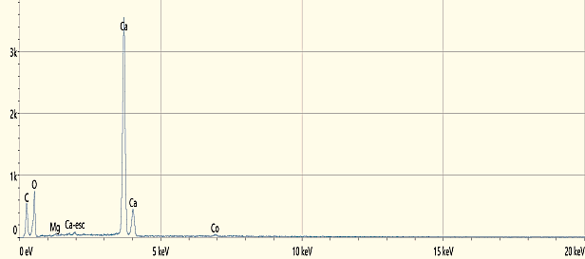
Element | Atomic %
C | 19.6
O | 60.9
Mg | 0.3
Ca | 18.9
Co | 0.3

b
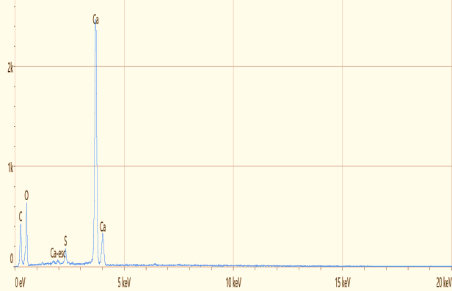
Element | Atomic %
C | 21.9
O | 59.5
S | 1.0
Ca | 17.6

c
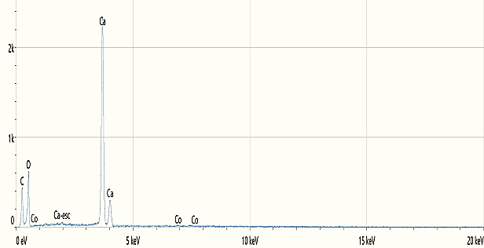
Element | Atomic %
C | 20.4
O | 61.6
Ca | 17.8
Co | 0.1

d
Figure S2. EDX spectra of eggshell samples: (a) untreated eggshell (ES) before Co(II) adsorption; (b) ES after Co(II) adsorption; (c) acid-treated eggshell (EST) before adsorption; (d) EST after Co(II) adsorption.

Figure S3. Equilibrium contact time for Co(II) adsorption onto untreated eggshell (ES) and acid-treated eggshell (EST) surfaces.

Figure S4. Effect of adsorbent (ES and EST) dosages on Co(II) adsorption.

Figure S5. Effect of temperature (°C) on Co(II) ion adsorption capacity on ES and EST surfaces.

Figure S6. Plot of log k_{d} against 1/T for Co(II) ion sorption on ES and EST surface.

Figure S7. Plot of log ΔGº against T for Co(II) ion sorption on ES and EST surface.

EST |  |  | ES |  |  | T(K)
∆Sº  kJ.(mol.K)⁻¹ | ∆Gº  kJ.mol⁻¹ | ∆Hº  kJ.mol⁻¹ | ∆Sº  kJ.(mol.K)⁻¹ | ∆Gº  kJ.mol⁻¹K⁻¹ | ∆Hº  kJ.mol⁻¹ | T(K)
+0. 92787 | -14.1009 | + 12.508 | +0. 88191 | -13.1765 | + 11.970 | 288
+0. 92787 | -15.8157 | + 12.508 | +0. 88191 | -15.1357 | + 11.970 | 303
+0. 92787 | -16.9685 | + 12.508 | +0. 88191 | -16.1763 | + 11.970 | 318
+0. 92787 | -18.3327 | + 12.508 | +0. 88191 | -17.1769 | + 11.970 | 333
Table S1. Thermodynamic variables for the adsorption of Co ion on ES and EST surface.

Table S2. Comparison of Freundlich, Temkin, and Langmuir isotherm model parameters for Co(II) adsorption onto untreated eggshell (ES) and acid-treated eggshell (EST) surfaces.
surfaces |  | Parameters | Isotherm models
EST | ES | Parameters | Isotherm models
0.248 | 2.324×10⁻⁵ | K_{f} (mg/g) | Freundlich
2.77 | 10.471 | 1/n | Freundlich
0.361 | 0.095 | n | Freundlich
0.997 | 0.914 | R² | Freundlich
0.56 | 0.354 | K_{T} (L/mg) | Temkin
11.18 | 44.814 | B (J/mole) | Temkin
0.955 | 0.956 | R² | Temkin
-2.445 | -0.373 | Q_{m} (mg/g) | Langmuir
-0.227 | -0.282 | K_{L} (L/mg) | Langmuir
0.931 | 0.809 | R² | Langmuir
-0.0966 | -0.0763 | R_{L} at Co 50 ppm | Langmuir

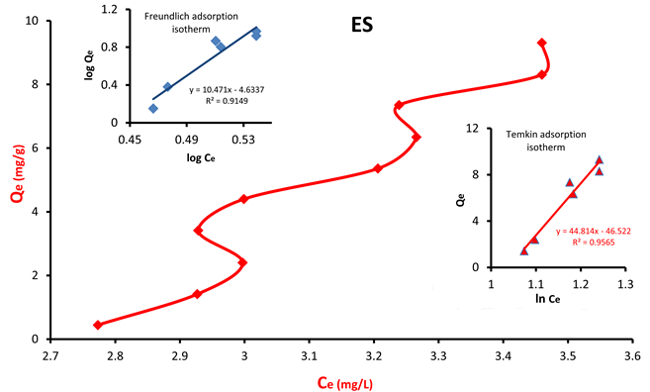

Figure S8. Freundlich and Temkin isotherm plot of adsorbed Co(II) ion on ES surface.

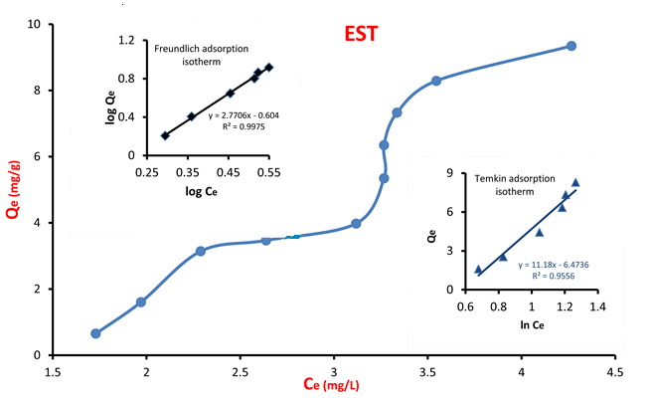

Figure S9. Freundlich and Temkin isotherm plot of adsorbed Co(II) ion on EST surface.

Figure S10. Langmuir adsorption isotherm of Co²⁺ on (ES and EST) surfaces.

