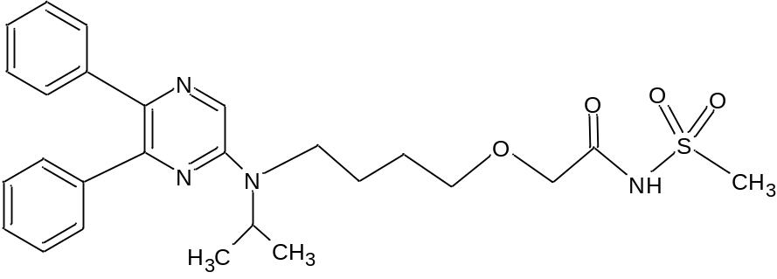
Figure S1. Chemical structure of SLP.
Table S1. Chromatographic system suitability parameters
Retention factor^{a,*} (1-10)^{b} | Resolution^{a,*}  (>2)^{b} | HETP^{a,*}  (<1 mm)^{b} | Tailing factor^{a,*}  (<2 mm)^{b} | Asymmetry factor^{a,*}  (<2)^{b} | Retention time (min)
8.44 | 3.10 | 0.78 | 1.3 | 0.82 | 6.40
*mean values of the parameters of all the points in calibration study are mentioned
ªAverage values
^{b}Recommended value

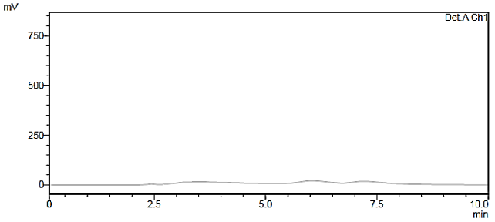
(a)
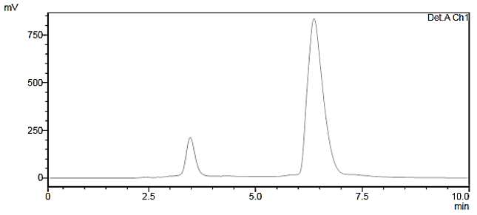
(b)
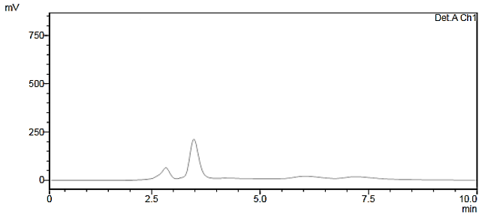
(c)

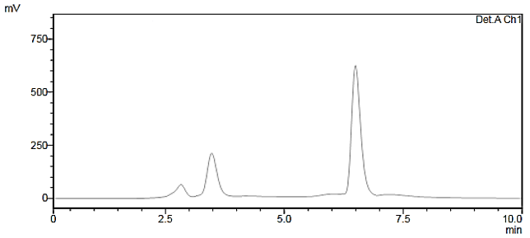
(d)
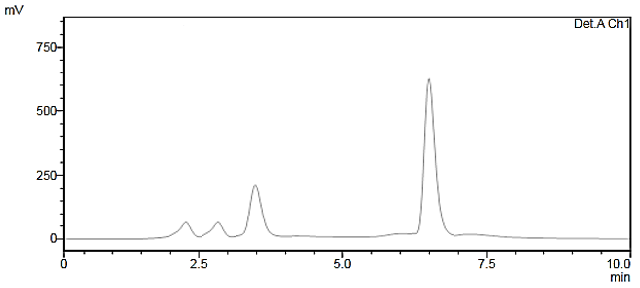
(e)
Figure S2. a: blank (aqueous medium), b: standard solution (10 ng/mL standard selexipag solution), c: blank plasma sample, d: 10 ng/mL selexipag spiked to plasma, e: plasma sample of volunteer after t_{max}.

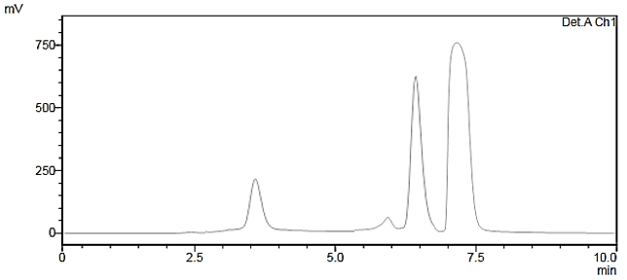
Figure S4: Chromatograms illustrating the effect of NBD-Cl concentration on derivatization efficiency (NBD-Cl concentration 0.020 mmol).
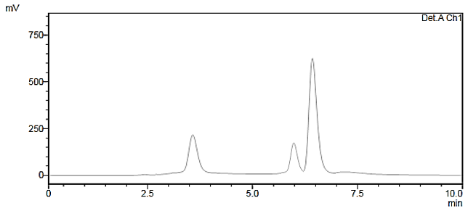
Figure S5: Chromatograms illustrating the effect of pH on derivatization efficiency (pH=8.0).
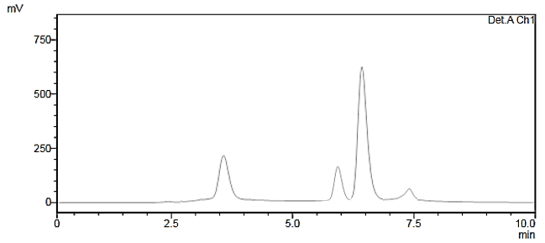
Figure S6: Chromatograms illustrating the effect of temperature on derivatization efficiency (Temperature=75 °C).

Figure S7: Effect on NBD-Cl concentration on derivatization reaction.

Figure S8: Effect of pH on derivatization reaction.

Figure S9: Effect of temperature on derivatization reaction.

