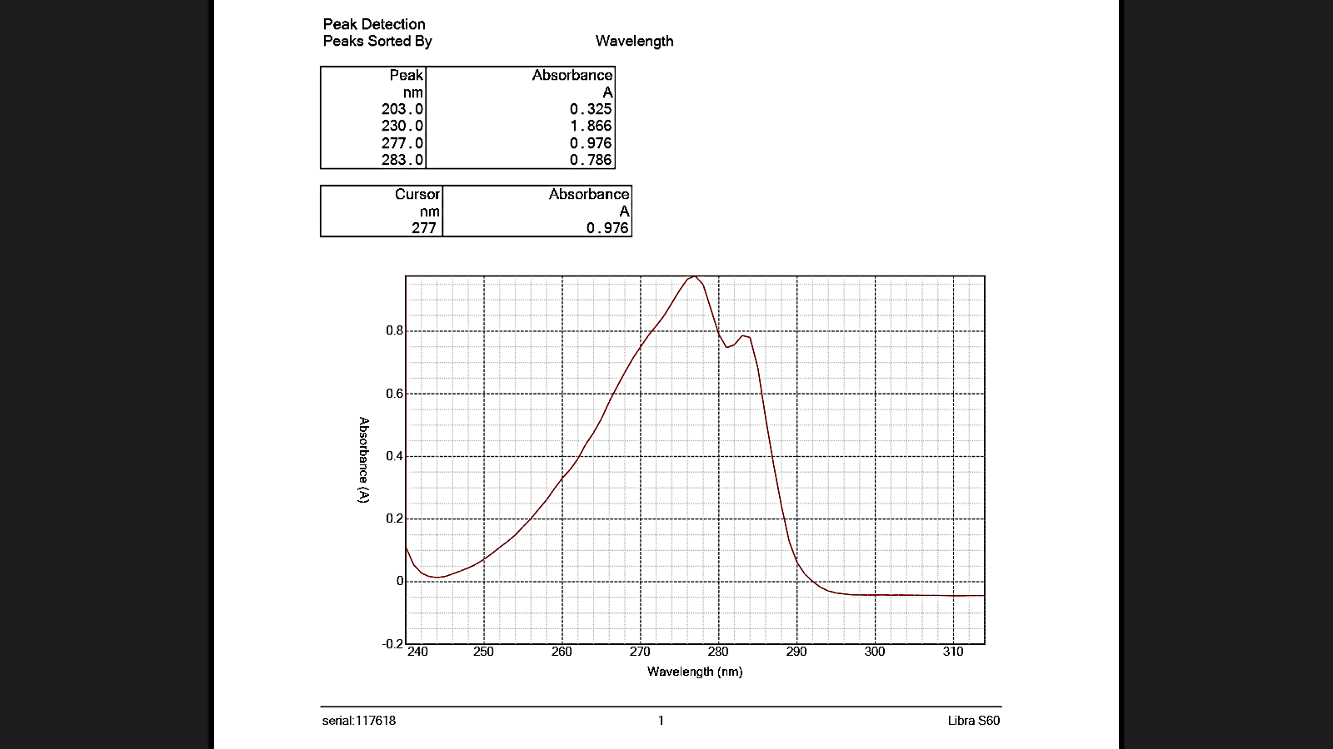
Figure S1. UV-Vis spectrum of the ion-association complex formed between SMX and [NiCl₄]²⁻ in the presence of Triton X-114.

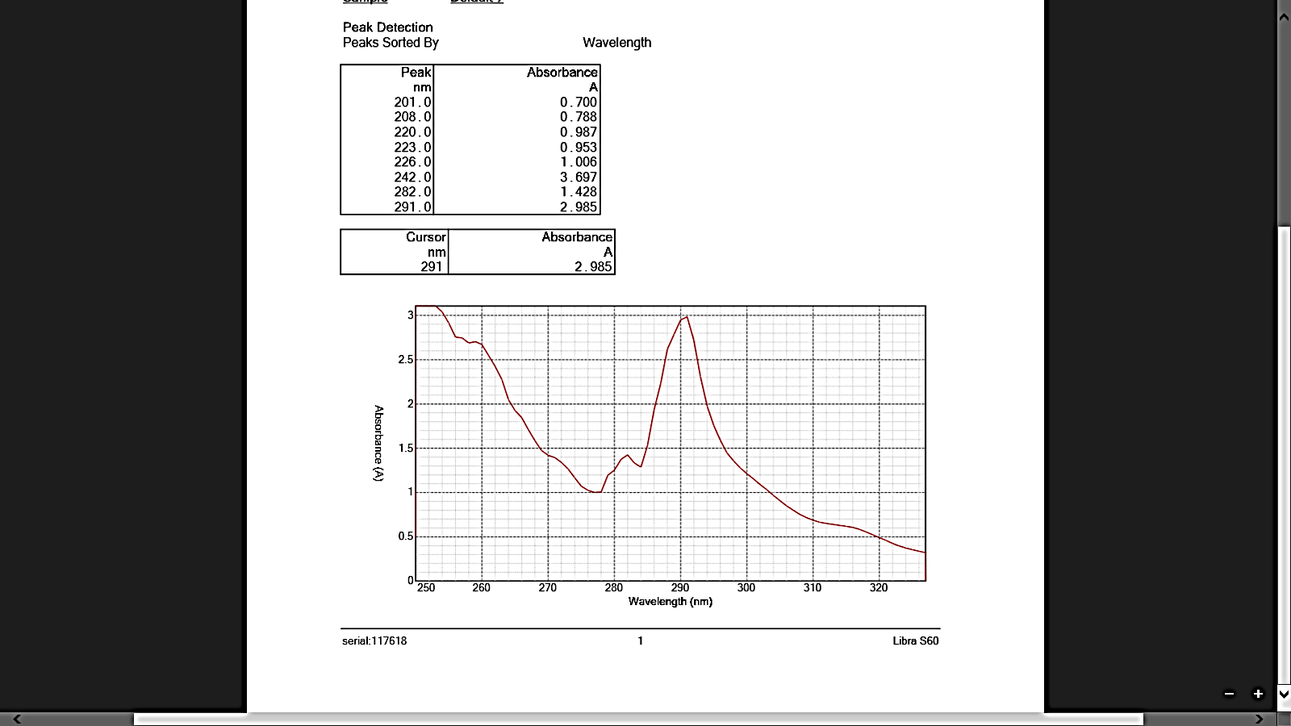
Figure S2. UV-Vis spectrum of the ion-association complex formed between SMX and [NiCl₄]²⁻ in the presence of Triton X-114 and Tween 80.

Figure S3. Effect of Ni(II) ion concentration on the formation of the SMX–[NiCl₄]²⁻ ion-association complex.

Slope=930.038
Figure S4. Variation of absorbance with SMX  concentration at constant [Ni(II)] for stoichiometric analysis of the ion-association complex. | Figure S5. Variation of absorbance with Ni(II)  concentration at constant [SMX] for stoichiometric analysis of the ion-association complex.

Table S1. Maximum absorption wavelength (λₘₐₓ) and dielectric constants of the selected organic solvents.
Solvent | D | TritonX-114 |  |  | TritonX-114 + Tween80
Solvent | D | λ _{max} | φ(D) | F(D) | λ _{max} | φ(D) | F(D)
Ethyl Glycol | 37.000 | 277 | 0.947368 | 0.96 | 277 | 0.947368 | 0.96
Methanol | 32.700 | 291 | 0.940653 | 0.954819 | - | 0.940653 | 0.954819
Ethanol | 24.550 | 291 | 0.921722 | 0.94012 | 277 | 0.921722 | 0.94012
2-propanol | 18.300 | 276 | 0.896373 | 0.920213 | 277 | 0.896373 | 0.920213
2-butanol | 17.260 | 277 | 0.890471 | 0.915541 | 277 | 0.890471 | 0.915541
Di chlorobenzene | 9.930 | - | 0.817017 | 0.856184 | - | 0.817017 | 0.856184
Tri-butyl phosphate | 8.290 | 278 | 0.784715 | 0.829352 | 277 | 0.784715 | 0.829352
Ethyl acetate | 6.000 | 277 | 0.714286 | 0.769231 | 277 | 0.714286 | 0.769231
3-chloro toluene | 5.550 | - | 0.694656 | 0.752066 | - | 0.694656 | 0.752066
Chloroform | 4.810 | 272 | 0.655766 | 0.717514 | - | 0.655766 | 0.717514
Benzene | 2.270 | - | 0.388379 | 0.458484 | - | 0.388379 | 0.458484
Hexane | 1.890 | 277 | 0.307958 | 0.372385 | 277 | 0.307958 | 0.372385

Figure S6. Correlation between λₘₐₓ and dielectric properties of selected solvents.

Figure S7. Kinetic profiles of absorbance over time for the SMX–[NiCl₄]²⁻ complex.

Figure S8. Logarithmic plot of initial rate as a function of SMX concentration (initial rate method).

Table S2. Analytical parameters for the initial rate method.
Surfactant | Linear range (M) | Least square  $$\log{V=\log{Ḱ+n\log{C}}}$$ |  | Correlation  Coefficient  (R²) | LOD  (M) | LOQ  (M)
Surfactant | Linear range (M) | Intercept ($\log{Ḱ )}$ | Slope (n) | Correlation  Coefficient  (R²) | LOD  (M) | LOQ  (M)
TritonX-114 | 2.0×10⁻⁴ – 7.9×10⁻⁴ | 1.5473 | 0.161 | 0.9990 | 0.994 | 3.01
TritonX-114 + Tween 80 | 2.0×10⁻⁴ – 7.9×10⁻⁴ | 1.7136 | 0.0922 | 0.9997 | 0.359 | 1.087

Figure S9. Calibration curve for sulfamethoxazole determination using the CPE–LIE method.

Table S3. Chromatographic parameters used for the determination of sulfamethoxazole.
Parameter | Optimized HPLC conditions
Column | C18
Flow rate | 1ml/ min
UV | 200 nm
Mobile phase | MeCN : Distilled water  40 :60
Add | 0.4 % $H_{2}{SO}_{4}$

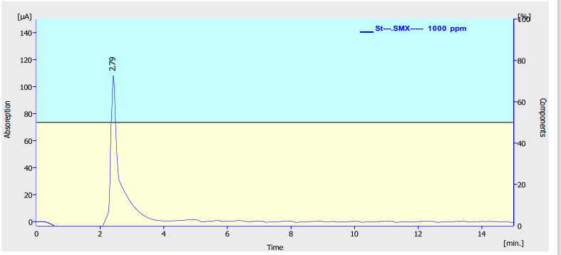
Figure S10. HPLC chromatogram of the sulfamethoxazole (SMX) standard solution (1000 ppm).
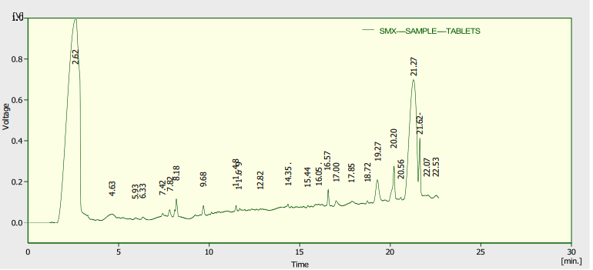
Figure S11. HPLC chromatogram of sulfamethoxazole (SMX) in the tablet formulation (Septrin).

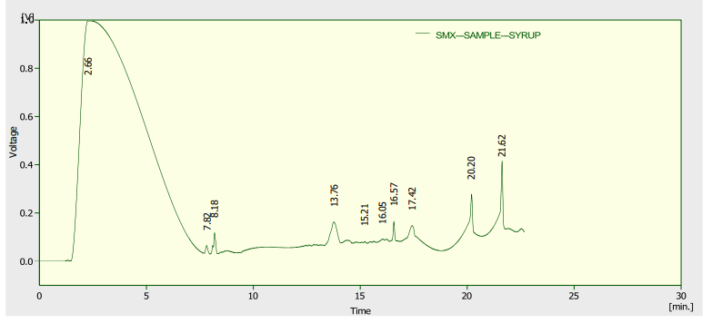
Figure S12. HPLC chromatogram of sulfamethoxazole (SMX) in the oral suspension formulation (KINDIPRIM).

