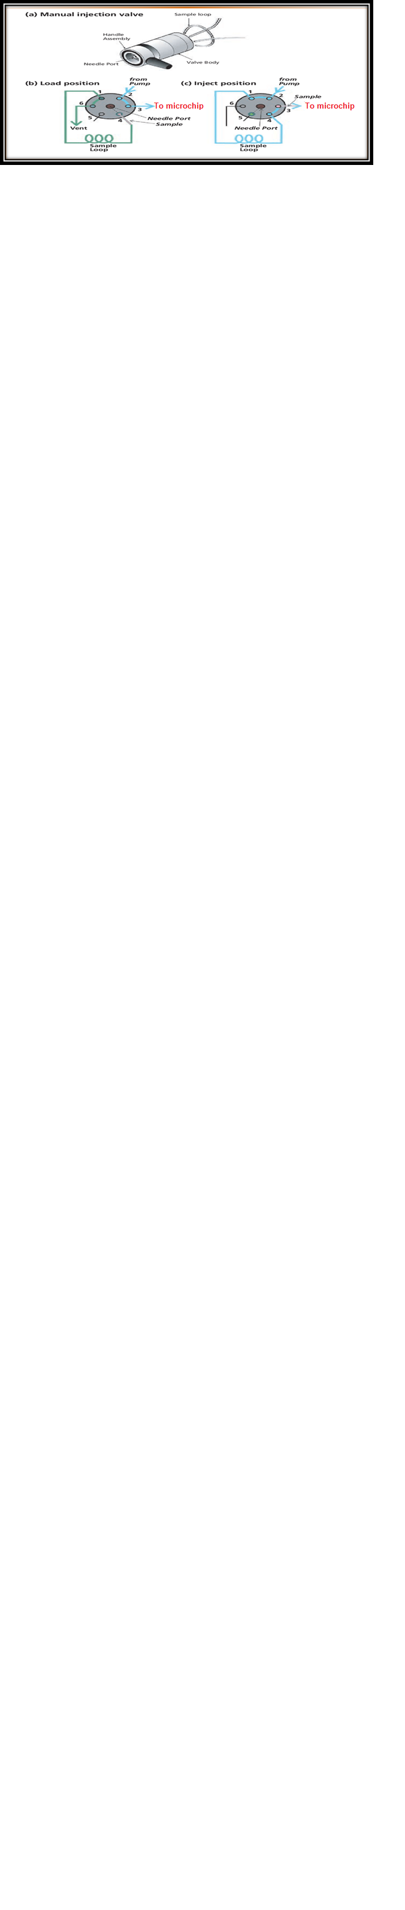
Figure S1. Manual one-position universal valve (a); sample loading process (b); and sample injection process (c).

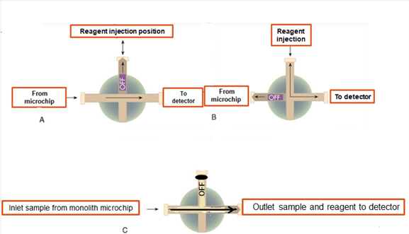
Figure S2. Schematic representation of the reagent injection and flow toward the detector.
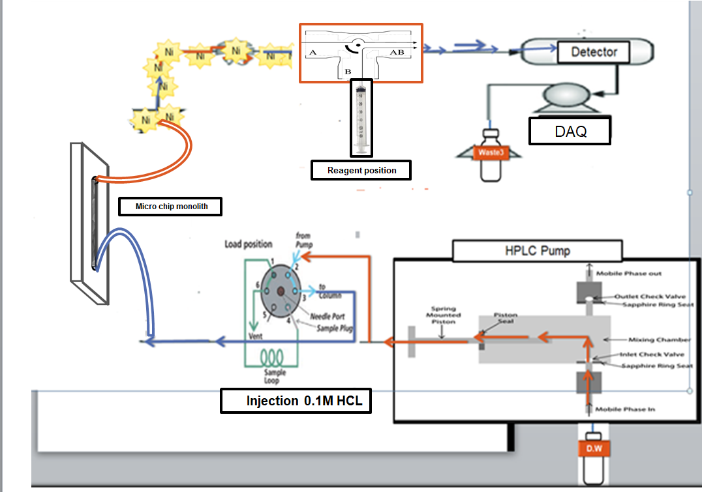
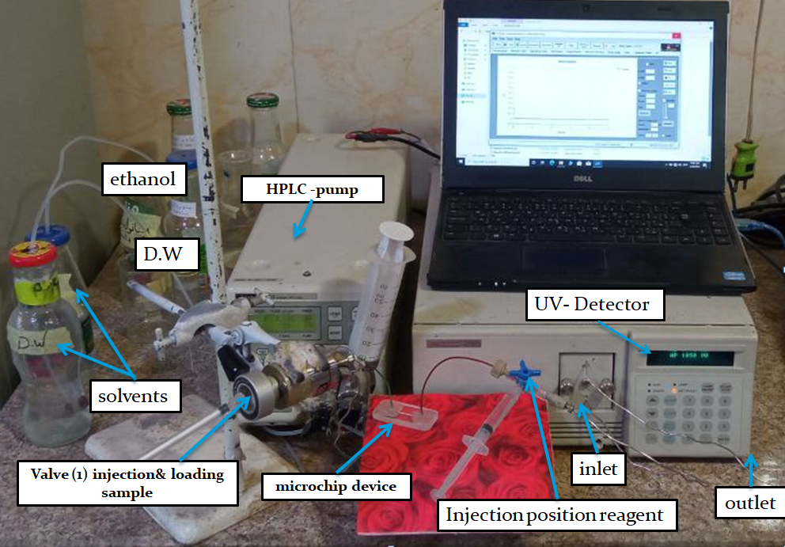
Figure S3. Schematic and photographic representation of the connection of the monolithic microfluidic chip to other components of the system.

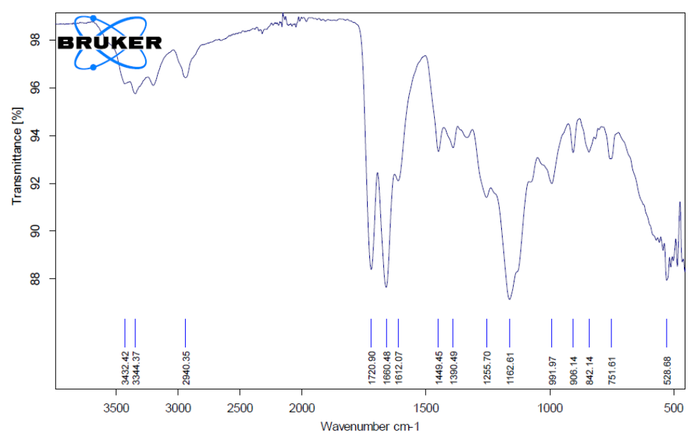
Figure S4. FTIR spectrum of the GMA-co-AAc-co-AAm monolithic material.

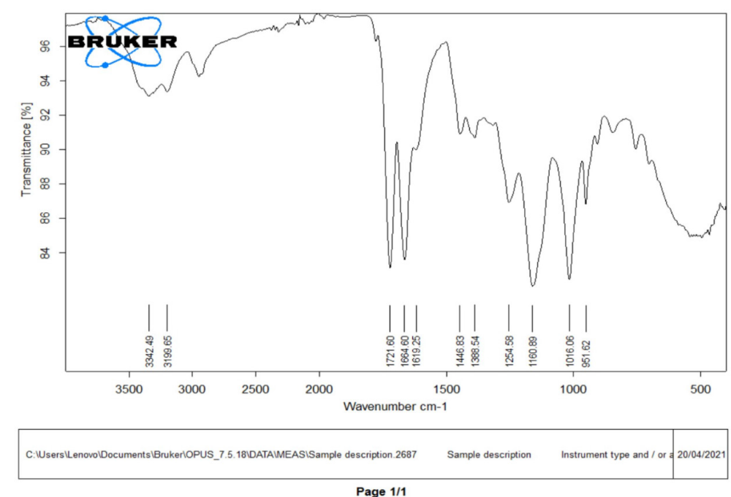
Figure S5. FTIR spectrum after opening the epoxy ring in the monolith.
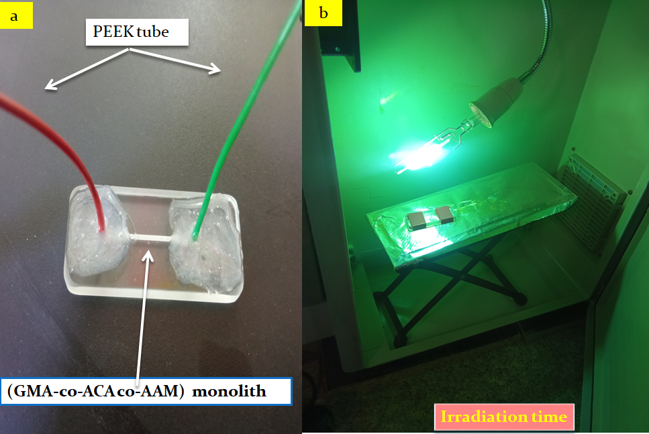
The formed monolith

Figure S6. The formed monolith inside the microchip.
Table S1. The Permeability of the Glass Microchip Monolith.
Pressure (psi) | Flow rate (mL min⁻¹) | No.
55 | 0.01 | 1
57 | 0.03 | 2
60 | 0.05 | 3
62 | 0.08 | 4
65 | 0.10 | 5
76 | 0.30 | 6
87 | 0.50 | 7
94 | 0.60 | 8
105 | 0.80 | 9
118 | 1.00 | 10

Figure S7. The permeability of the microchip monolith.
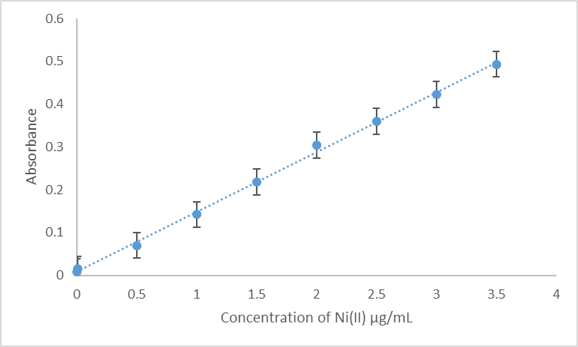
Figure S8. Calibration curve for Ni(II) under optimized conditions: 7·10⁻⁵ mol L⁻¹ MPDADPI, 0.1 mol L⁻¹ HCl, deionized water as the carrier, and a flow rate of 0.1 mL min⁻¹.

