Table S1. Description and origin of the investigated food samples.
Sample No. | Sample description | Production country
1 | Chewing gum₁ | Turkey
2 | Chewing gum₂ | Turkey
3 | Chewing gum₃ | Turkey
4 | Tahina | Jordan
5 | Powder juice (Shmpart) | Turkey
6 | Powder juice (Squeez) | Syria
7 | Powder juice (Tang) | Egypt
8 | Milk Cake | Jordan
9 | Coffee Creamer | Turkey
10 | Powder drink | United States
11 | Fruits Skittles | United Kingdom
12 | Halawa | Saudi Arabia
13 | Mentos | Turkey
14 | Hummus | Jordan
15 | Marshmallows | China
16 | White chickpeas | Egypt
17 | Gravel chocolate | Jordan
18 | Jelly candy | Syria
19 | Cake ornament | Jordan
20 | Candy | Turkey
21 | Nescafe 2in 1 | United Arab Emirates
22 | Powder juice (Darina) | Lebanon
23 | Salad dressing | Jordan
24 | Wafer | Turkey
25 | Bread cakes | Jordan

Table S2. The operation conditions for the ICP-OES device.
Parameter | Setting
Auxiliary Gas | 0.5 L/min
Rf power | 1350 W
View Direction | Axial
Nebulizer pressure | 30 psi
Cool Gas flow | 14.5 L/min
Exposure Time | 5 sec
Wash Time | 45 sec
Uptake Time | 45 sec

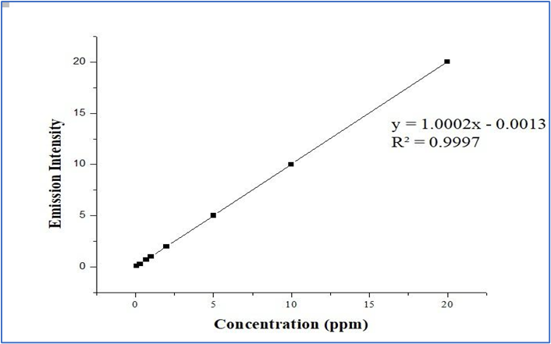

Figure S1. Calibration curve for titanium (Ti) obtained using ICP-OES.

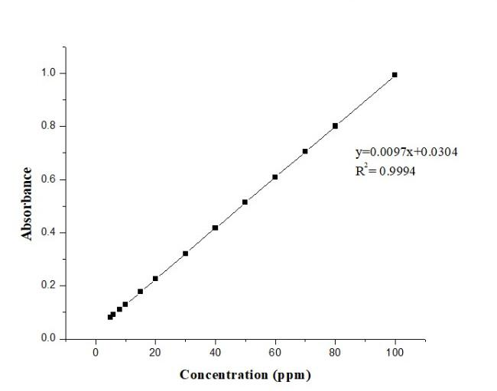

Figure S2. Calibration curve of Ti(IV) standard obtained by UV–Visible spectrophotometry at a wavelength of 407 nm.
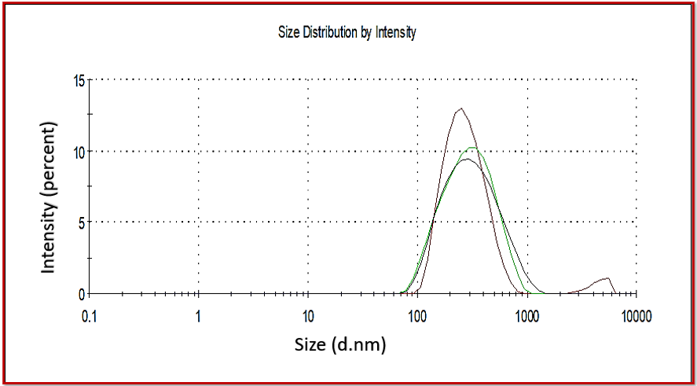
Figure S3. Hydrodynamic particle size distribution of food-grade pure titanium dioxide (TiO₂), showing the average particle size and distribution range as measured by dynamic light scattering (DLS).
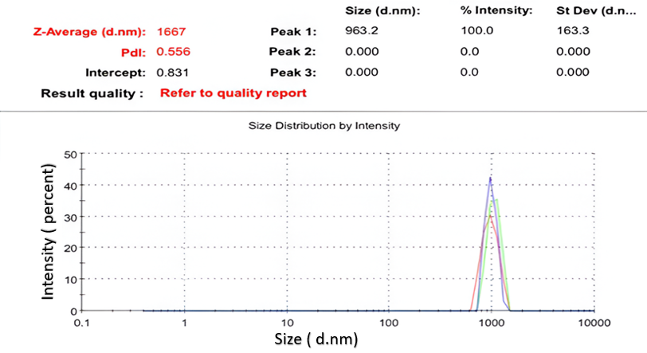
Figure S4. Hydrodynamic particle size distribution of a Mentos sample extract, obtained using Dynamic Light Scattering (DLS), indicating the predominant particle size range and size heterogeneity.

