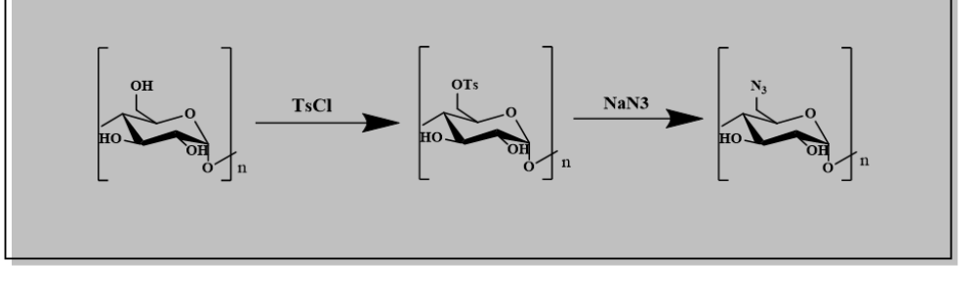
Scheme S1. Synthesis of tosylated starch (2) and azido-starch (3).

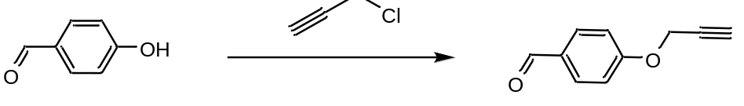
Scheme S2. Synthesis of 4-(prop-2-yn-1-yloxy)benzaldehyde (4).
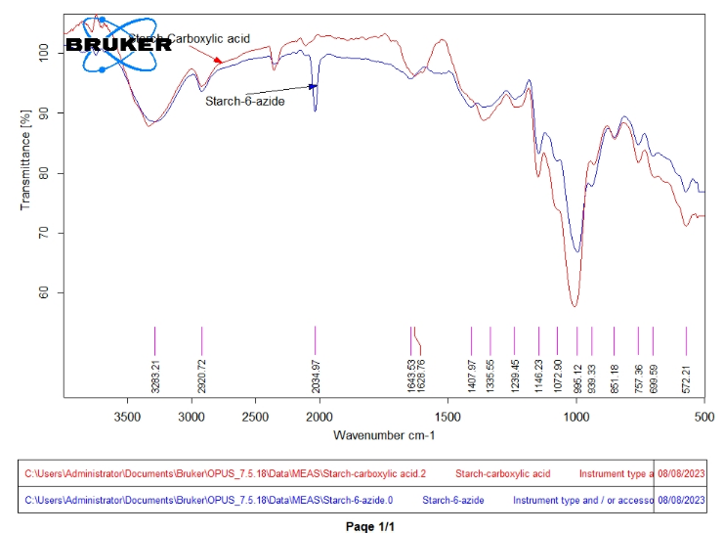

Figure S1. FT-IR spectrum of TABS polymer shows key functional group transitions.

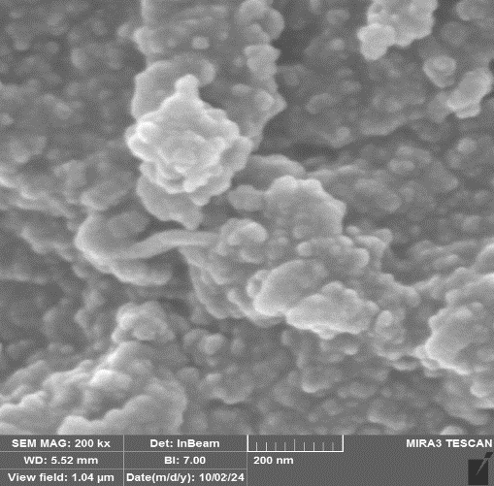

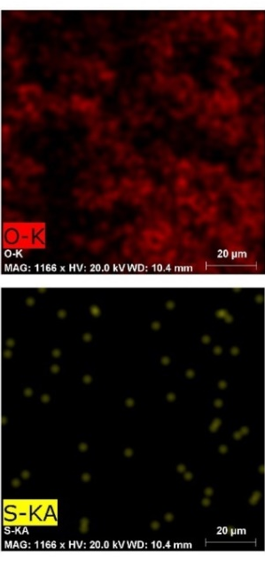
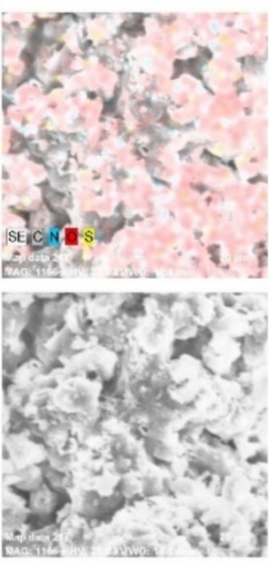
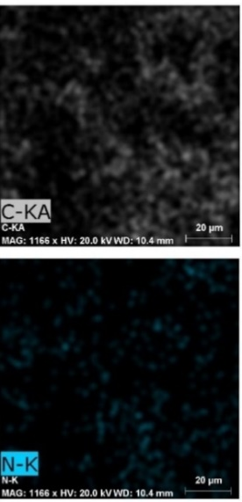
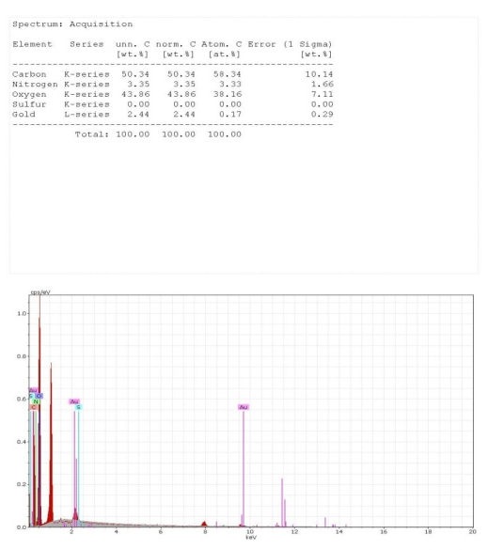
Figure S2. SEM image of TABS polymer showing aggregated and porous morphology.

Figure S3. EDX spectrum of TABS confirming elemental composition.

Figure S4. Effect of adsorbent dosage on Pb(II) removal efficiency.

Figure S5. Effect of contact time on Pb(II) adsorption by TABS.

Figure S6. Effect of solution pH on Pb(II) adsorption by TABS.

