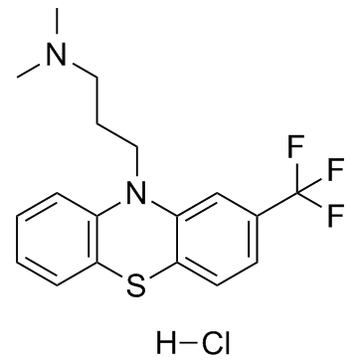
. HCl

Figure S1. Triflupromazine hydrochloride structure [4].

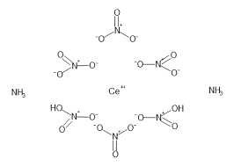

Figure S2. CAN molecule structure [13].

Figure S3. The spectrum of the colored product (C).

Figure S4. The calibration curve of the colored product.
1 0.8 0.6 0.4 0.2 0
Ve/Vd+Ve
Figure S2. Job’s plot illustrating the relationship between absorbance and mole fraction of the TFM.HCl–CAN system.

Table S1. Stability constants (β), dissociation factors (α), and absorbance values (A_{m}, A_{s}) for the TFM.HCl–CAN complex at various temperatures.
β (L·mol⁻¹) | α | A_{m} | A_{s} | T (K) | t (°C)
1.40 × 10⁶ | 0.080 | 0.556 | 0.511 | 288 | 15
1.53 × 10⁶ | 0.077 | 0.593 | 0.547 | 293 | 20
1.54 × 10⁶ | 0.077 | 0.581 | 0.536 | 298 | 25
2.01 × 10⁶ | 0.068 | 0.558 | 0.52 | 303 | 30
2.17 × 10⁶ | 0.065 | 0.533 | 0.498 | 308 | 35
3.86 × 10⁶ | 0.049 | 0.504 | 0.479 | 313 | 40
2.52 × 10⁶ | 0.061 | 0.459 | 0.431 | 318 | 45
3.75 × 10⁶ | 0.050 | 0.437 | 0.415 | 323 | 50

