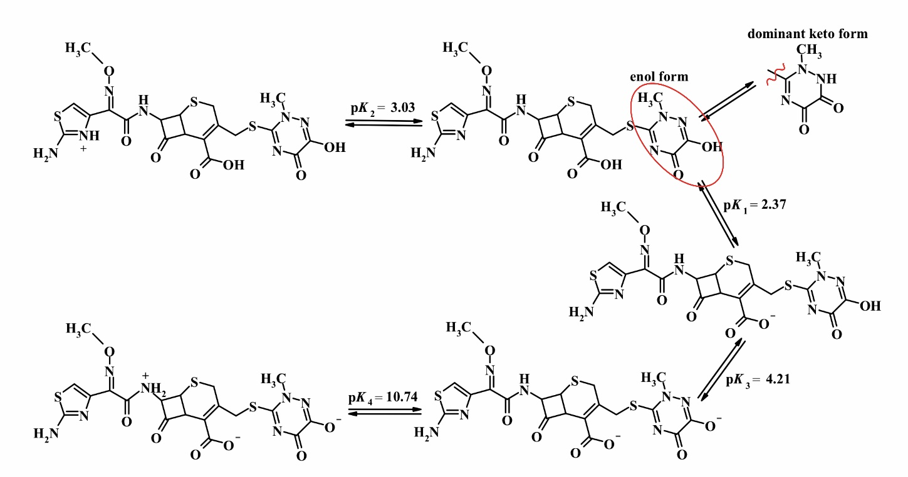

Scheme S1. Ground-state equilibria of different prototropic species of CEFTR in aqueous solutions.

Table S1. Physico-chemical characteristics of the studied antibiotics.
Antibiotic | Some characteristics
Ceftriaxone  6R,7R)-7-{[(2Z)-2-(2-amino-1,3-thiazol-4-yl)->2-(methoxyimino)acetyl]amino}-3-{[(2-methyl-5,6-dioxo-1,2,5,6-tetrahydro-1,2,4-triazin-3-yl)thio]methyl}-8-oxo-5-thia-1-azabicyclo[4.2.0]oct-2-ene-2-carboxylic acid. Gross formula: C₁₈H₁₈N₈O₇S₃.  CAS number: 73384-59-5; M= 554.58 g·mol⁻¹. | White or light yellow crystalline powder, odorless.  Solubility: 40 mg⋅mL⁻¹ in water, 1 mg⋅mL⁻¹ in ethanol.  logK_{ow}= 0.46 [2-5].

Table S2. Physico-chemical characteristics of o-cresol.
Reagent | Some characteristics
o-cresol, 2-methylphenol  CAS number 95-48-7;  M=108.1 g·mol⁻¹; | Colorless crystals.  Solubility: 0.23 g·L⁻¹ in water, soluble in acetone and chloroform, sparingly soluble in diethyl ether and ethanol.  Melting point = 30.9°C. Boiling point = 190.9°C.

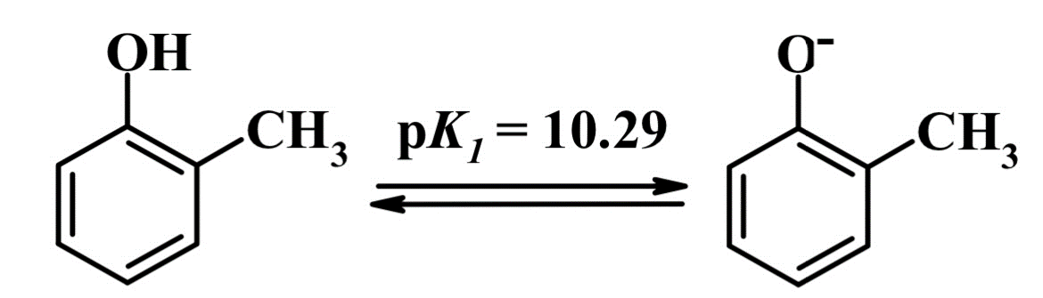
Scheme S2. Ground-state equilibria of o-cresol prototropic species in aqueous solutions [28].

Table S3. The order of adding reagents during the interaction of diazotized CEFTR with CRES. Diazotization conditions: С_{HCl}=12.0 М (initial conc., V=0.5 mL),
С_{CEFTR} = 7.5·10⁻⁵ М, C_{NaNO2} = 7.5·10⁻⁴ M, t_{diazot.}= 5 min. Conditions for azo coupling: С_{CRES}= 7.5·10⁻⁴ M, С_{NaOH}= 0.16 M; λ_{max} =516 nm, l = 1 cm; Р=0.95, n=5.
The order of adding components to the mixture | 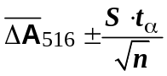
[CEFTR + HCl + NaNO₂]_{5min} + reagentdissolved by 4.0 М NaOH solution | 0.649 ± 0.025
[HCl + NaNO₂ + CEFTR]_{5min} + reagentdissolved by 4.0 М NaOH solution | 0.547 ± 0.031
[NaNO₂ + CEFTR + HCl]_{5min} + reagentdissolved by 4.0 М NaOH solution | 0.475 ± 0.022

Table S4. Spectrophotometric methods of the CEFTR determination using the azo coupling reaction.
Reagent | Reaction conditions | λ_{max},  nm | ε_{max}·10⁻³, L⋅mol⁻¹⋅⋅cm⁻¹ | Limit of detectionμg⋅mL⁻¹ | Linear Range,  μg⋅mL⁻¹
sodium nitrite[23] | CEFTR aqueous solution + 1% citric acid + 0.5% NaNO₂ | 500 | − | 10 | 12.5–200
sodium nitrite[19] | CEFTR aqueous solution + 0.1% NaNO₂ + 0.5 M HCl→stand for5min atroom temperature + 2% NaOH | 559 | 2.3836 | − | 50-150
3-amino phenol (AP) [21] | CEFTR aqueous solution + 0.1 % sodium nitrite + 1 M HCl → cooling in an ice bath at-3– -2 °C + stirring for 10 min + 2 % sulphamic acid+ 0.3% AP → cooling on ice bath for 10 min | 505 | 1.6 | 1.07458 | 20–160
2-naphthol [18] | CEFTR aqueous solution + 0.1 M HCl + 1 mg·mL⁻¹ NaNO₂ → reaction time 5 min→ 1 mg·mL⁻¹  2-naphthol solution | 510 | 4.045 | 0.726 | 1–20
2-naphthol [19] | CEFTR aqueous solution +0.1% NaNO₂ + 0.5 M HCl → stand for5min atroom temperature + 0.5% 2-naphthol (dissolved in methanol) + 2% NaOH | 554.5 | 4.5613 | − | 30-150
β-naphthol [20] | CEFTR aqueous solution + 0.6 M HCl +1 % sodium nitrite→ cooled at-4-0⁰С for 20 min + 4%urea + shaking for few min + β-naphthol (dissolved in 50% KOH) + 0.7 mol L⁻¹ KOHstirring for 20 min → 10% v/v Triton X−114 + 2.0 mL hexadecyl-trimethylammonium bromide, 5% Na₂SO₄→ shaking for 3 min →for cloud point extraction the mixture is heated in a water bathat 60 °C for 50 min→ cooling on ice bath for 10 min + 0.5 mL of absolute ethanol | 545 | 9.8 | 0.194 | 2.5–62.5
p-dimethylamino benzaldehyde (DMAB) [16] | 10% NaNO₂ +CEFTR aqueous solution + HCl → mixture cooled 0-5 ⁰С +stirring for 20 min → 13 mLof ice-cold water + stand in icefor 15 min + 0.3%DMAB (dissolved in 0.0625 M H₂SO₄) →stay at room temperature 30 min (or at 70 ⁰C for 5 min) + methanol | 420 | 9.25 | 5.093 | 25–60
N-(1-naphthyl)-ethylenediamine dihydrochloride [17] | CEFTR aqueous solution + 0.1% NaNO₂ + 0.5M HCl→ stand for5min atroom temperature + 2% ammonium sulphamate +0.2%N-(1-naphthyl)-ethylenediamine dihydrochloride (or 0.5 %resorcinol, or 1% phloroglucinol) | 530 | 2.3836 | – | 50–150
resorcinol [17] |  | 518 | 4.2648 | – | 20–100
phloroglucinol [17] |  | 460 | 8.9416 | – | 10–50
2.5-dimethylphenol (2.5-DMP) [11] | CEFTR aqueous solution + 0.57M HCl + 0.14M NaNO₂→ cooling in an ice bath at0 – 5 ᵒC for 10 min +2·10⁻³ M 2,5-DMP (2.5·10⁻³ M 4-TBP) + 0.45 M KOH | 520 | 4.377 | 0.482 | 3.0–50
4-tret-butylphenol (4-TBP) [11] |  | 500 | 7.446 | 0.284 | 10–30
8-oxyquinoline [25] | CEFTR aqueous solution + 12.0 M HCl + 0.06 M NaNO₂ → 3.0∙10⁻² M 8-oxyquinoline disolved in 4.0 M NaOH | 550 | 14.5 | 0.28 | 0.33–94.3
o-cresol | CEFTR aqueous solution +  12.0 M HCl + 9.3·10⁻³M NaNO₂ →4.6∙10⁻³M o-cresol disolved in 4.0 M NaOH | 516 | 6.90 | 0.22 | 0.22–51.30

