Table S1. Characteristics of sildenafil tablet samples.
Sample No. | Product Name | Dosage form (mg) | Place of Manufacture | Expiration Date | Lot No.
1 | FAST 4S | 100 | India | Jul-24 | SD 069
2 | NIZAGRA | 100 | India | May-25 | 645F
3 | BLACK COBRA | 100 | India | Oct-24 | T1902045
4 | PUNERGY | 150 | India | Jan-25 | 3703
5 | PUREGREY | 100 | India | Apr-25 | 3661
6 | SIL FIX | 100 | India | Aug-24 | 6098
7 | SUPERGRA | 100 | India | Mar-26 | CB901
8 | VEGERA | 100 | India | Mar-22 | FST-01
9 | YOGA 100 | 100 | India | Jul-25 | PUG-01
10 | VIAGRA | 100 | Morocco | Jan-26 | FT3744
11 | VIGOREX | 100 | Morocco | Nov-26 | 29

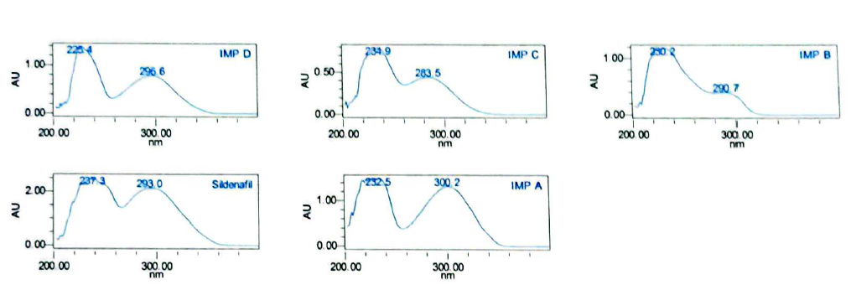
Figure S1. UV spectra of sildenafil and impurities A–D.

Table S2. System Suitability Parameters.
Injection | Retention time (min) | Area | Symmetry Factor | Theoretical plates
1 | 4.554 | 18826845 | 1.4 | 10475
2 | 4.553 | 18874524 | 1.4 | 10559
3 | 4.554 | 18865150 | 1.4 | 10569
4 | 4.553 | 18868737 | 1.4 | 10527
5 | 4.554 | 18894787 | 1.4 | 10500
6 | 4.553 | 18926331 | 1.4 | 10479
%RSD | 0.01 | 0.2

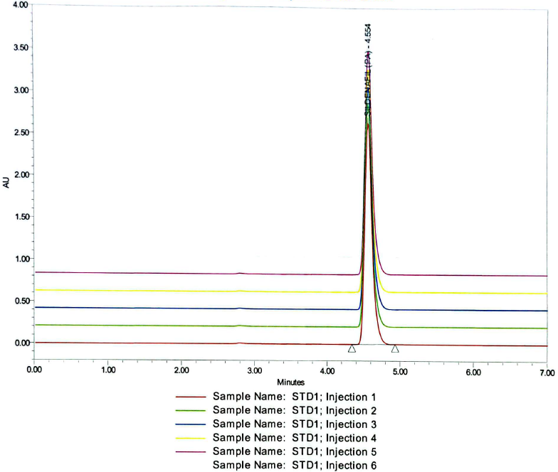
Figure S2. Representative chromatogram demonstrating system suitability.

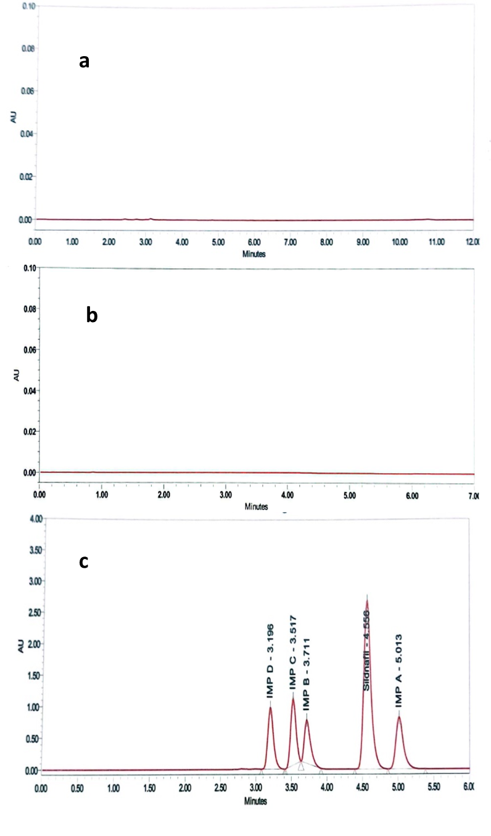
Figure S3. HPLC chromatograms for sildenafil citrate: (a) Blank, (b) Placebo, (c) Mixture of sildenafil citrate and related compounds.

