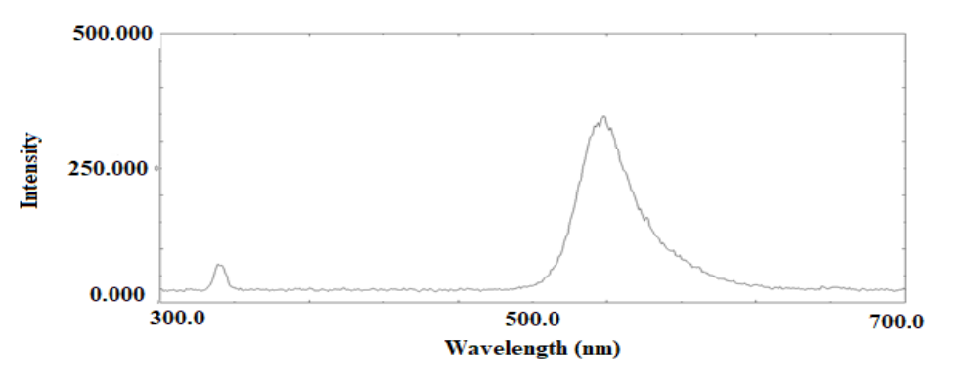
Figure S1. Emission spectrum of 4,5-dibromo fluorescein (DBF, 8 µg/mL) in aqueous solution.

Figure S2. Calibration curve of 4,5-dibromo fluorescein (DBF).
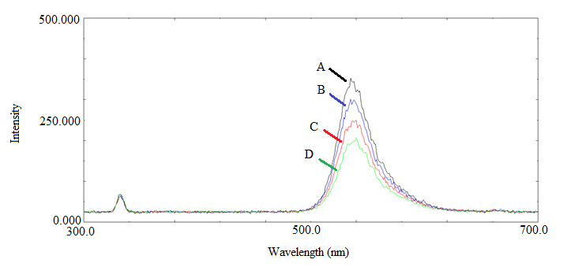
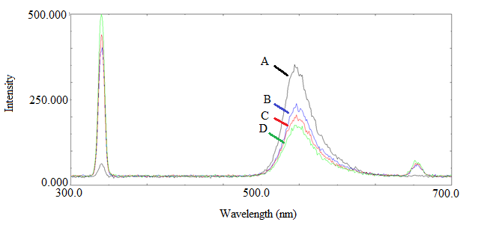
Figure S3. Fluorescence emission spectra of 4,5-dibromo fluorescein (DBF, curve A) and its ion-pair complexes with (a) captopril at 4 µg/mL (B), 8 µg/mL (C), and 12 µg/mL (D), and (b) clopidogrel bisulfate at 4 µg/mL (B), 8 µg/mL (C), and 12 µg/mL (D). All measurements were performed at λex = 330 nm.

Figure S4. Standard calibration curves for captopril (CPL) and clopidogrel bisulfate (CLO) obtained using the proposed spectrofluorimetric method with 4,5-dibromo fluorescein (DBF) as the fluorescent reagent. Fluorescence quenching (ΔF) was measured at λ_ex = 330 nm and λ_em = 540 nm over the concentration ranges 0.4–14 µg/mL (CPL) and 0.4–8 µg/mL (CLO).

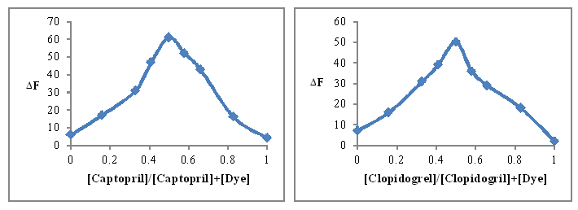
Figure S5. Continuous variation (Job’s method) plots for the complexes of captopril (CPL) and clopidogrel bisulfate (CLO) with 4,5-dibromo fluorescein (DBF).

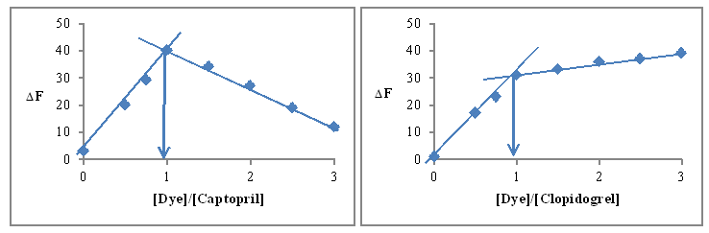
Figure S6. Molar ratio plots for the interaction of captopril (CPL) and clopidogrel bisulfate (CLO) with 4,5-dibromo fluorescein (DBF). The diagrams further support a 1:1 stoichiometry for the drug–dye complexes.
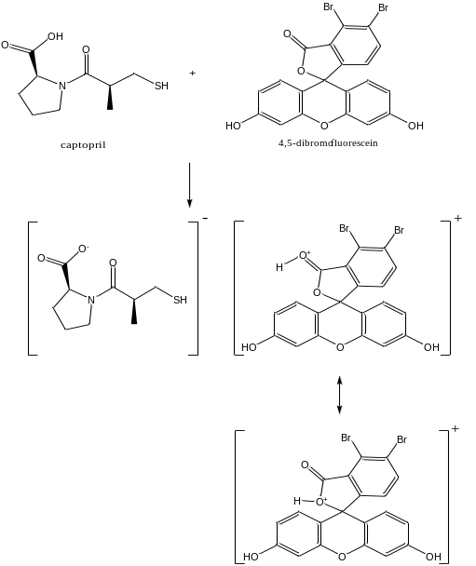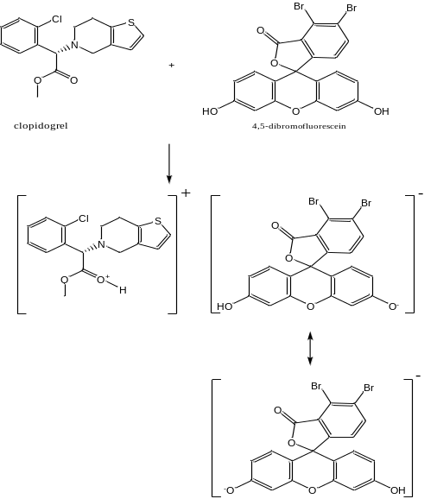

Figure S7. Proposed interaction mechanism between captopril (A) and clopidogrel bisulfate (B) and 4,5-dibromo fluorescein (DBF), illustrating ion-pair complex formation.
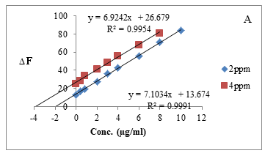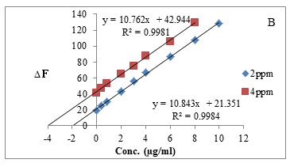
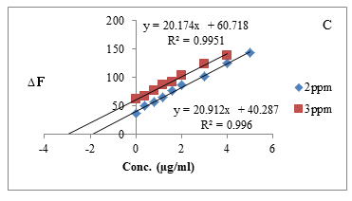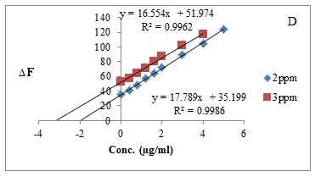
Figure S8. Standard addition calibration plots for the determination of captopril (CPL) and clopidogrel bisulfate (CLO) in commercial tablet formulations using the proposed spectrofluorimetric method.
(A) Captopril tablets (Iraq, 25 mg),
(B) Captopril tablets (Cyprus, 50 mg),
(C) Clopidogrel bisulfate tablets (Iraq, 75 mg),
(D) Clopidogrel bisulfate tablets (India, 75 mg).
Each plot shows the linear relationship between fluorescence quenching (ΔF) and drug concentration at different spiking levels, confirming the accuracy of the standard addition method (R² ≥ 0.995 for all cases).

Table S1. Comparison of analytical variables for the proposed method with those in the literature.
Parameter | Captopril – Proposed | Captopril – Literature [7] | CLO – Proposed | CLO – Literature [33]
Remarks | Fluorescence | Fluorescence | Fluorescence | Charge-transfer
Reagent used | DBF | Ortho-phthaldehyde | DBF | Chloranel
λ_ex (nm) | 330 | 334 | 330 | —
λ_em (nm) | 540 | 448 | 540 | —
Linearity range (µg/mL) | 0.4–14 | 20–450 | 0.4–8 | 5–40
Correlation coefficient R² | 0.9988 | 0.9993 | 0.9962 | 0.9990
LOD (µg/mL) | 0.263 | 6.4 | 0.061 | —
LOQ (µg/mL) | 0.796 | 19.5 | 0.185 | 1.2
Recovery (%) | 99.58 | 99.88 | 99.68 | 100.75

