Supplementary data

Efficacious method for free-sugar alcohols and cyclitols content in various medicinal plants in the Jordanian market intended for therapeutic cases

Jafar H. Alzoubi¹*, Sharif Arar¹*, Mahmoud Alawi¹,Ali Alnawaiseh²
¹Department of Chemistry, School of Science, The University of Jordan, Amman, 11942, Jordan
² Department of Chemistry and Chemical Technology, Tafila Technical University, P.O. Box 179, 66110, Tafila, Jordan

*Corresponding Author
Prof. Dr. Sharif H. Arar
ORCID: 0000-0001-9396-0518
Dr. Jafar H. Alzoubi
ORCID: 0009-0001-5732-3033

Table S1. Results of instrument precision by injecting the 80 µg/L sugars mix standard in triplicate
Sugars standard | Area ratio for injection 1 | Area ratio for injection 2 | Area ratio for injection 3 | x̄ ± SD | CV%
D-Pinitol | 41572 | 41574 | 41575 | 41573.67 ± 1.53 | 0.04
D-Chiro-inositol | 19848 | 19847 | 19842 | 19845.67 ± 3.21 | 0.02
Myo-inositol | 29258 | 29252 | 29254 | 29254.67 ± 3.06 | 0.01
D-Mannitol | 25315 | 25314 | 25317 | 25315.33 ± 1.53 | 0.01

Table S2. Results of instrument precision by injecting the 40 µg/L sugars mix standard in triplicate
Sugars standard | Area ratio for injection 1 | Area ratio for injection 2 | Area ratio for injection 3 | x̄ ± SD | CV%
D-Pinitol | 19175 | 19174 | 19178 | 19175.67 ± 2.08 | 0.01
D-Chiro-inositol | 10821 | 10822 | 10827 | 10823.33 ± 3.21 | 0.03
Myo-inositol | 14697 | 14693 | 14699 | 14696.33 ± 3.06 | 0.02
D-Mannitol | 12355 | 12352 | 12357 | 12354.67 ± 2.52 | 0.02

Table S3. Results of instrument precision by injecting the 10 µg/L sugars mix standard in triplicate
sugars standard | Area ratio for injection 1 | Area ratio for injection 2 | Area ratio for injection 3 | x̄ ± SD | CV%
D-Pinitol | 7468 | 7461 | 7464 | 7464.33 ± 3.51 | 0.05
D-Chiro-inositol | 5406 | 5405 | 5408 | 5406.33 ± 1.53 | 0.03
Myo-inositol | 3675 | 3675 | 3677 | 3675.67 ± 1.15 | 0.03
D-Mannitol | 3704 | 3703 | 3709 | 3705.33 ± 3.21 | 0.09

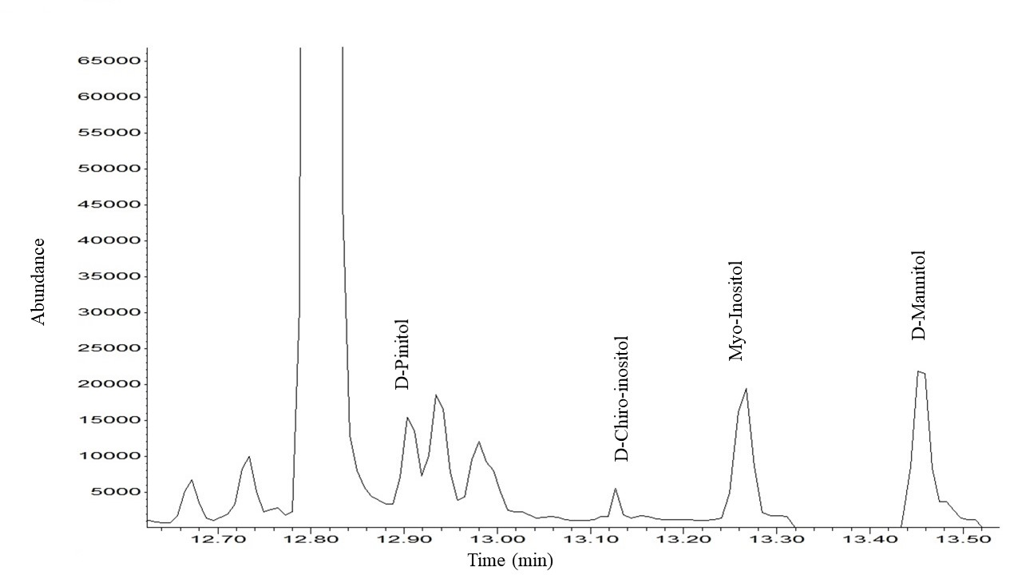
Figure S1. Representative GC chromatogram of a Bacopa Monnieri sample for sugars analysis in the SIM mode

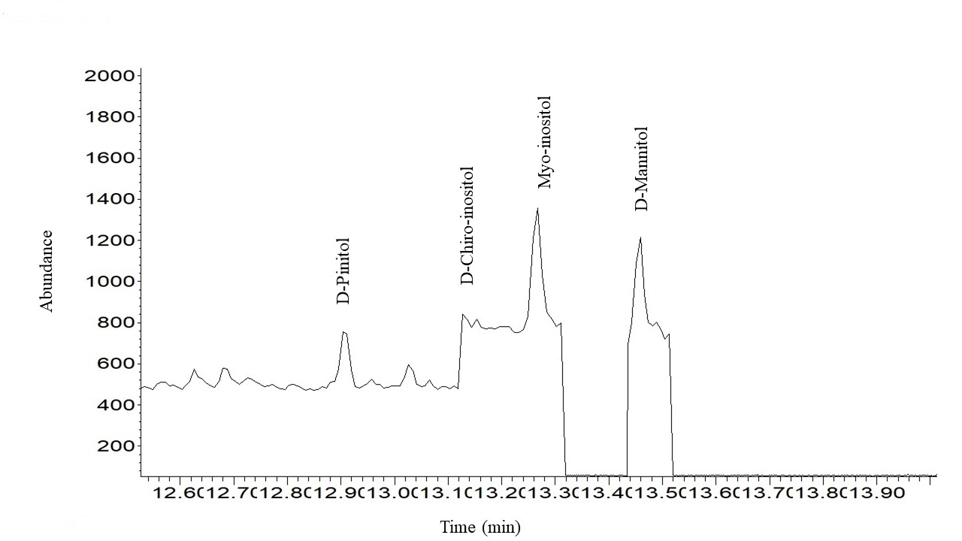
Figure S2. Representative GC chromatogram of a Saussurea Costus sample for sugars analysis in the SIM mode

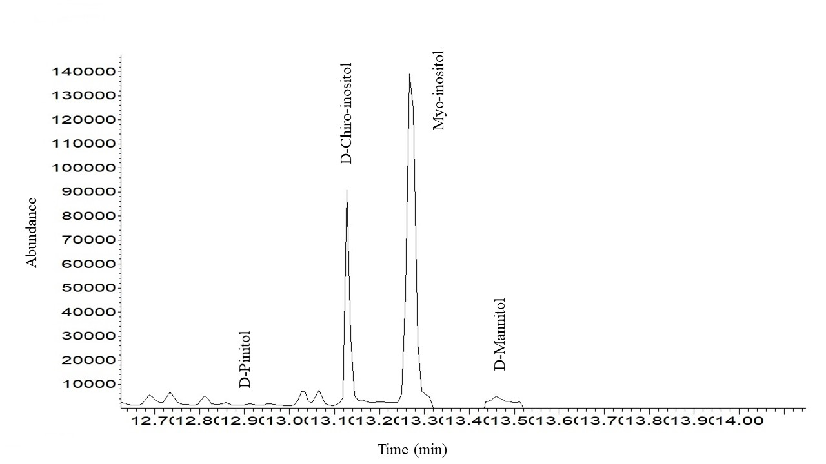
Figure S3. Representative GC chromatogram of a Tribulus Terrestris sample for sugars analysis in the SIM mode

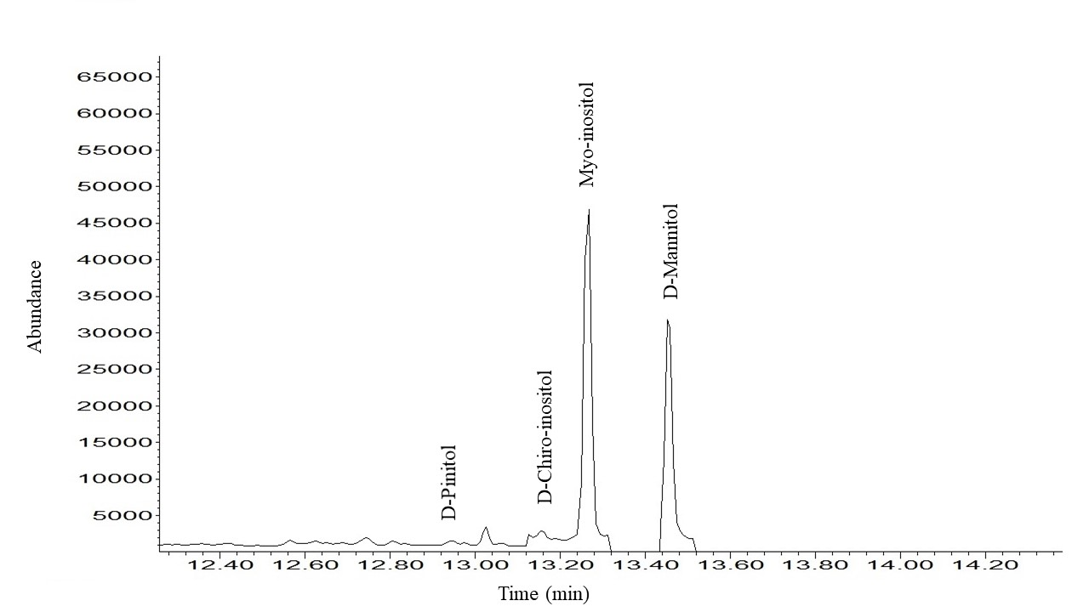
Figure S4. Representative GC chromatogram of a Illicium Verum sample for sugars analysis in the SIM mode

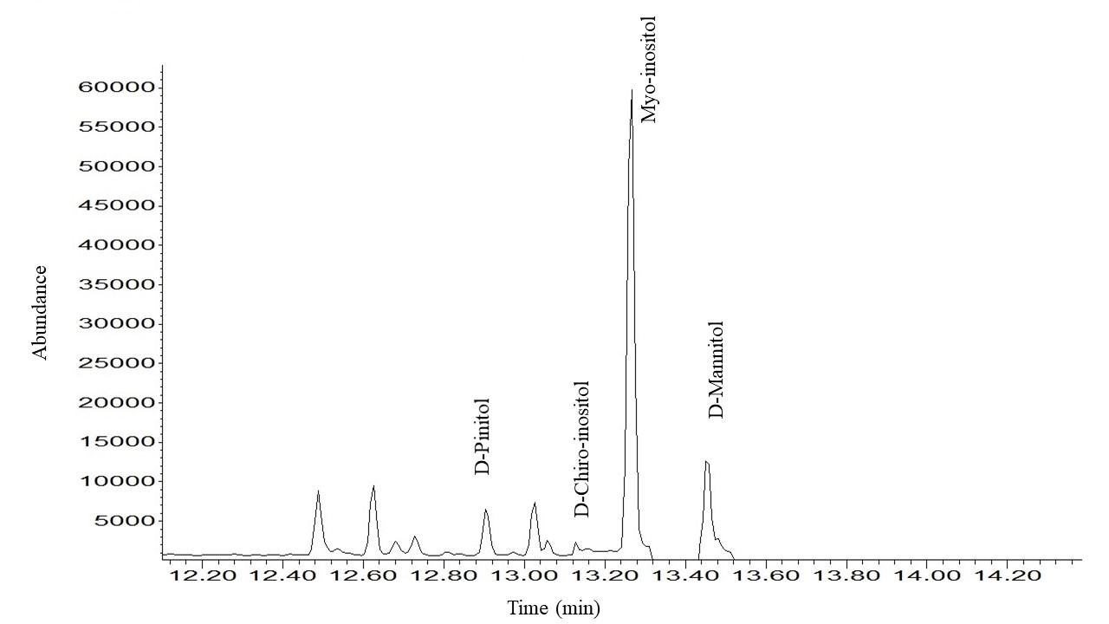
Figure S5. Representative GC chromatogram of a Scutellaria Lateriflora sample for sugars analysis in the SIM mode

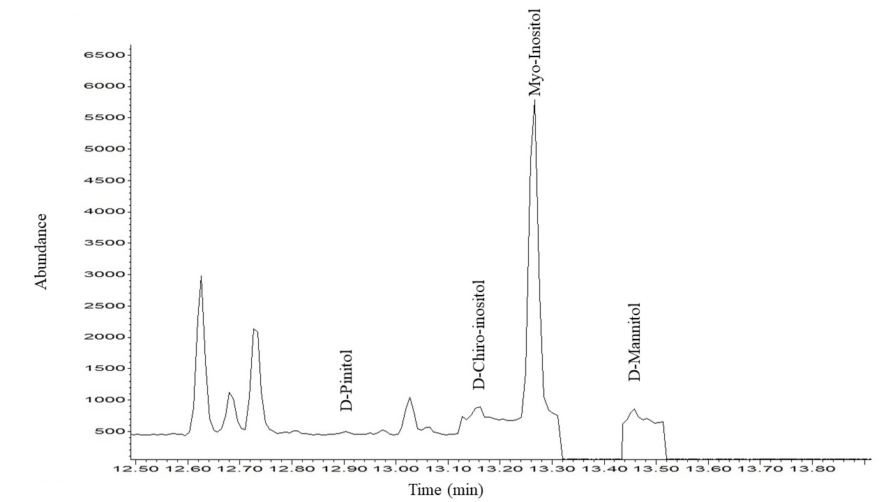
Figure S6. Representative GC chromatogram of a Peganum Harmala sample for sugars analysis in the SIM mode

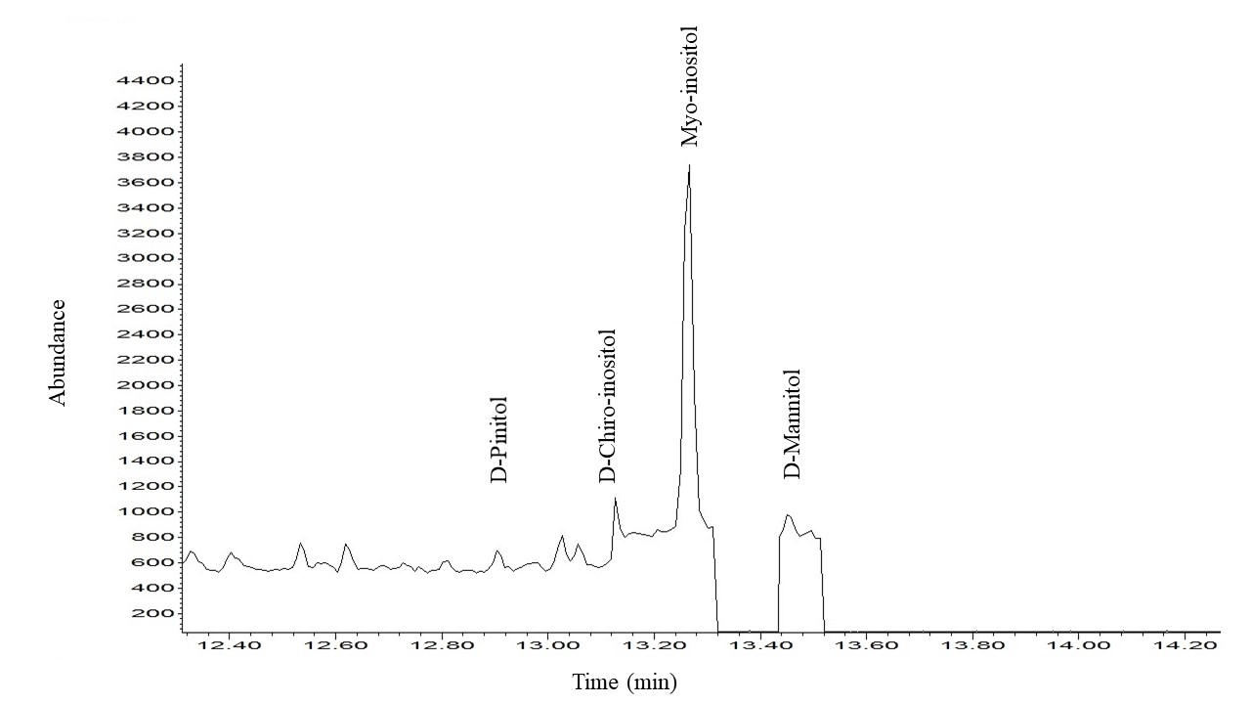
Figure S7. Representative GC chromatogram of a Boswellia Carterii sample for sugars analysis in the SIM mode

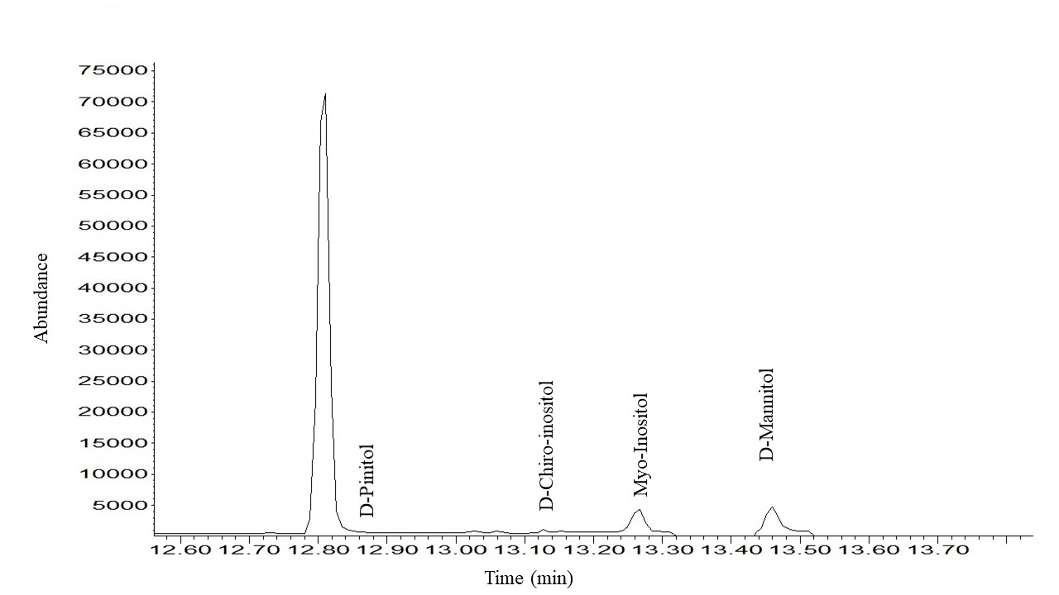
Figure S8. Representative GC chromatogram of a Artemisia Judaica sample for sugars analysis in the SIM mode

